**Montana Behavior Initiative Summer Institute**

**2017**

**Implementing MTSS for Behavior in High School Settings**

**June 20, 2017**

Hank Bohanon

hbohano@luc.edu

<http://www.hankbohanon.net> (sign up for updates)

<https://twitter.com/hbohano>

<https://www.facebook.com/hank.bohanon>

Please feel free to use these materials. Please let me know if they are helpful to you and how you use them to support your efforts.

**I. Establishing an organizational plan for MTSS**

**Enduring Understanding:** Be able to identify the components of preparing staff and establishing buy-in related to school climate.

**Essential Questions:** How do you prepare systems to enhance the support in your environment (e.g., human, financial, structural)?

**Connections to MBI Self-Assessment:**

* MBI facilitator/team receive in-service on the MBI process and philosophy
* School/district professional development opportunities allow team and staff to continually add to or improve the MBI process



*Note.* Montana College and Career Readiness Anchor Standards for Speaking and Listening 9th and 10th grade students. See http://opi.mt.gov/pdf/CCSSO/ELA_GradeLevel_9_10.pdf

**Comprehension and Collaboration:** Prepare for and participate effectively in a range of conversations and collaborations with diverse partners, building on others’ ideas and expressing their own clearly and persuasively. Integrate and evaluate information presented in diverse media and formats, including visually, quantitatively, and orally. Evaluate a speaker’s point of view, reasoning, and use of evidence and rhetoric.

**Presentation of Knowledge and Ideas:** Present information, findings, and supporting evidence such that listeners can follow the line of reasoning and the organization, development, and style are appropriate to task, purpose, and audience. Make strategic use of digital media and visual displays of data to express information and enhance understanding of presentations. Adapt speech to a variety of contexts and communicative tasks, demonstrating command of formal English when indicated or appropriate. **Exploring Other Secondary Schools**

**What is working well?**

* Making small changes leads to greater success
* Let people see change from improvement and they will buy-in
* Focusing on improving classroom instruction
* Defining expected behaviors by location
* Change takes at least 3-5 years
* Providing training for your staff
* Providing training for you core team
* Having common language around spirit
* Having a core team to guide your efforts
* Having district support for your implementation efforts at the building level
* Having access to data, like My Voice Surveys has been useful
* Providing samples of high school related MBI content to staff
* Showing staff proof that an intervention will work
* Having access to external coaches to support your implementation efforts
* Having an internal coach/facilitator to guide your efforts
* Look at your data, tie them back to your efforts
* Encouraging staff to praise students
* Use of acknowledgment and rewards for students can be helpful
* Having assemblies related to MBI by grade level
* Branding your efforts – having t-shirts, stickers
* Connecting your expectations to graduation – Be a Graduate
* Having a process to onboard new students when they come in to your school
* Still having corrective consequences for students’ misbehavior
* Myth busting, focusing in behavior will actually *give* you more instructional time
* Including student voice in meaningful ways to improve your school climate
* Having a youth committee around climate
* Students from high school visit elementary schools to talk about climate/expectations
* Being aware of students who are entering your school from lower grades who need more support
* Home visits to students before they enter the school
* Having mental health professionals based in the school
* Helping staff identify common problems to solve
* Having interventions in place like check and connect or mentoring
* Having MBI as a part of a standing agenda item at every faculty meeting
* Having an MBI related onboarding process for new staff at the beginning of the year
* Using the MBI Blueprint to guide implementation efforts
* Other:

**Next Steps to Address**

* Maintaining success of approaches
* Addressing student trauma
* Getting buy-in for initiatives
* Dealing with mental health needs: depression, school phobia
* Alternative ways to help student earn credits
* Helping students who are homebound
* Shifting efforts to focus on college and career ready
* Prepare for turnover in staff and students with regard to your implementation efforts
* Addressing bullying
* Staff do not always want to address behavior, social or emotional needs of students; they would rather focus on content

Other:

Sample Interview Questions for developing buy-in (newer teams)

|  |  |
| --- | --- |
| What is going well in your school around behavior/discipline? |  |
| What are some of the barriers to teaching around discipline? |  |
| What would you like to change about your job AROUND DISCIPLINE? |  |
| Can you say anything about who, when, where, what, and why about problem behaviors and/or desirable behaviors occur in your building? |  |
| What have you liked/disliked about staff development in the past? |  |

Adapted from the work of Jim Knight by Hank Bohanon (hbohano@luc.edu) and the Louisiana PBS Project

Sample Interview Questions for developing buy-in (established teams)

Please answer the questions below about MTSS/PBIS.

1. What do you like MOST about the implementation of MTSS/PBIS?

2. What do you like LEAST about the implementation of MTSS/PBIS?

3. How do you feel the implementation of MTSS/PBIS could be IMPROVED?

4. How often do you hand out wristbands?

Circle ONE: Never Monthly Weekly

5. What suggestions do you have for reinforcers (rewards) for students? (Think of things

that may or may not cost money).

6. What suggestions do you have for reinforcers for teachers whose names are called

when a wristband is chosen?

Amy Kroll

9-12 Special Education Teacher/Transition Specialist

1829 Central Ave.

Auburn, NE 68305

(402)-274-4328

akroll@esu4.org

**Sample Results**

1. What do you like MOST about the implementation of PBIS?

Have seen an improvement in student behavior (5)

Uniformity and consistency (7)

Get to meet kids they don’t know

Lessons (2)

Kids pick up after themselves

Helps w/social skills

Teaches positive expectations

Wristbands (2)

½ hour of work time for teachers

Awareness of students doing positive things

Discussion of difficult topics with the kids

6-12 Building wide

See same kids every day for set amount of time

Positive behavior enforcement is more effective than negative

Kid’s reaction when name is drawn for wristband

Videos

Clear consequences, good rewards

Working w/students that need extra help

The review of major issues-parking, technology, hallway decorum

No Comment (2)

2. What do you like LEAST about the implementation of PBIS?

Repetition of simple lessons (6)

Lesson effectiveness (2)

Lessons are too elementary (2)

No feedback from teachers

Read-only topics

Wish it could extend to the classroom

Not being visible in other areas than the hall

Teaching partner’s lack of effort and attitude toward students

One partner does all the lessons, work, talking

Filing out the forms, forgetting about doing them (3)

Not having all the materials for the lessons beforehand

Most students have nothing to do (2)

Not everyone rewarding the same things

Students aren’t taking lessons seriously (2)

Rewarding behavior that should be expected from students

Clipboards

The lessons are getting shorter

Students are still treating the positives as jokes

Kids thinking they need a wristband for everything

I like everything about it!

Teachers need to be more consistent

No Comment (1)

3. How do you feel the implementation of PBIS could be IMPROVED?

Use multimedia for lesson presentation

Expand to classroom (4)

Increase rewards

More group activities

More speakers

Change lessons, too repetitive, gear toward high school (2)

Wristband stipulations need to be more clear-teachers are handing out

wristbands for behaviors not on the matrix

Shorter

How we recognize the wristband winners

Everyone following the same rules (2)

More activities to reinforce lessons

ARC Time is too long

Students have lost focus of purpose 2nd semester

More relevant movies on Youtube

Have monthly meetings w/teachers

Keep educating staff about steps to take various situations

Apply consequences withinin one day

No comment (13)

4. How often do you hand out wristbands?

Circle ONE: Never (7)

Weekly (4)

Monthly (18)

Other (3)

Amy Kroll

9-12 Special Education Teacher/Transition Specialist

1829 Central Ave.

Auburn, NE 68305

(402)-274-4328

akroll@esu4.org

**More Self-Assessment Tools**

Behavior See: – <http://www.pbisapps.org> see Self Assessment Survey;

Academic and behavior Self-Assessment for Buy-In (Niles West High School): <https://docs.google.com/spreadsheet/viewform?usp=sharing&formkey=dHFnSWtjRzdiY1k4M0w0b2kxWHMwNVE6MA#gid=0>

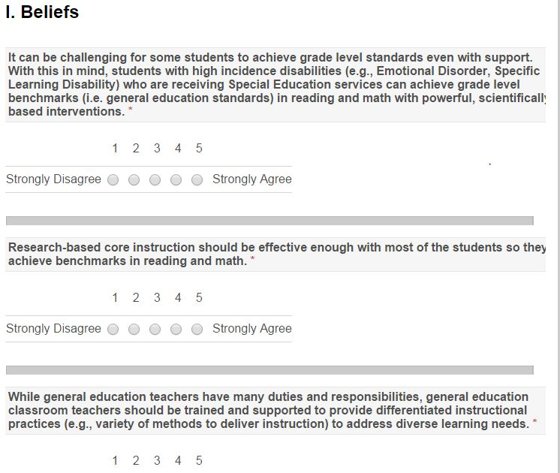

Adapted from http://www.floridarti.usf.edu/resources/program_evaluation/ta_manual_revised2012/index.html - See Tools for Examining Consensus Development

PBIS Action and Commitment Tool (PBIS-ACT) by Kevin Filter

See this link for more information <http://sbs.mnsu.edu/psych/psyd/people/filter/>

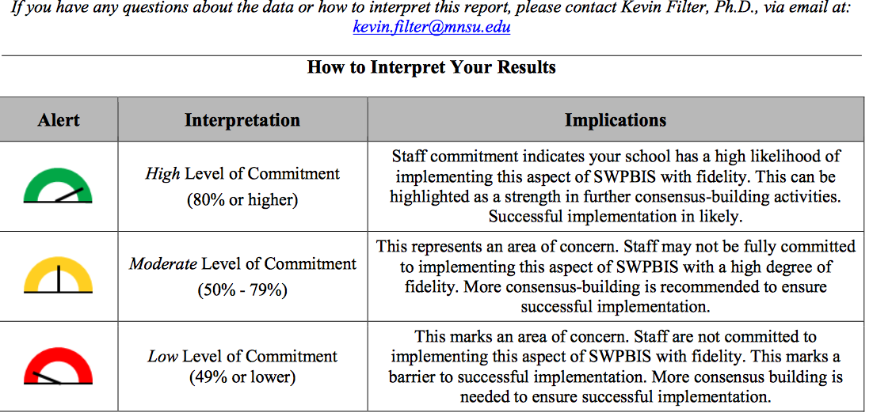Filter, K. J., Sytsma, M. R., & McIntosh, K. (2016). A Brief Measure of Staff Commitment to Implement School-Wide Positive Behavioral Interventions and Supports. *Assessment for Effective Intervention, 42*(1), 18-31.

**What works with EBPS**

See the components of evidenced-based practices

What Works with EBPs; Foreman, Olin, Hoagwood, Crowe, and Saka, 2009)

* the development of support from the administration (e.g., principal);
* obtaining support from teachers (e.g., priority);
* obtaining financial resources to sustain the project (e.g., FTE);
* providing effective training and coaching to increase fidelity;
* the alignment of the interventions with the schools’ goals, philosophy, policies, and programs (e.g., PLC);
* making sure program outcomes are visible to all stakeholders (e.g., share data); and
* developing processes to address the change in staff and administrators (e.g., plan, manual, specified roles).

Reflective question: Can you think of times when these were applied with success? Or perhaps non-examples?

Alternative: Participants will develop a short overview of MTSS on a napkin, they will present to colleague as though they were at a party and someone asked about MTSS.

Determine your next step.

Based on your team time discussion, list at least 2 action statements.

|  |  |  |
| --- | --- | --- |
| **WHAT NEEDS TO BE COMPLETED?** | **WHO** | **WHEN** |
| A. |  |  |
| B. |  |  |
| C. |  |  |
| D. |  |  |

**II. Healthy Team Functioning**

**Enduring Understanding:** Be able to identify and implement components of healthy teams

**Essential question:** How do you organize personnel in ways to support to enhance the support in your environment (e.g., teachers, school psychologists)?

**VT School Climate, 13 Dimensions of School Climate:**

Domain 4 Interpersonal Relationships: Leadership and Professional Relationships

**Connections to MBI Self-Assessment:**

* Administrative support for MBI team (letter of commitment, release time, inservice training for staff, respect for team decisions)
* Administrator is active and present for meetings/training
* MBI team is established
* MBI team meetings occur on a regular basis with consistent attendance
* MBI team has developed written short-term and long-term data-based action plans using research based strategies

**Defining your purpose**

**Tier 1 Mission and Vision**

Team structure and purpose (what is and is not the mission of your team, related to your school’s mission)?

**What is the mission** of your universal tier I team? (*Example The mission of the universal team is to increase the likelihood of positive behavior, social, emotional, and academic achievement of our students*). If needed, think about what you will not do..

|  |
| --- |
| Your statement? |

**What is the vision** (e.g., what are your outcomes – related to what do you want all students to know and be able to do?)

Examples:

* To work with students and their families to identify core climate supports to prevent health/behavioral/**attendance**/social/academic concerns.
* To identify reliable predictors of students performance.
* To determine likely source of problem and recommend changes to core interventions based on needs.
* To assist and support teachers, students, and parents in achieving efficient and effective universal interventions.

|  |
| --- |
| Your statement? |

**Sample Model**

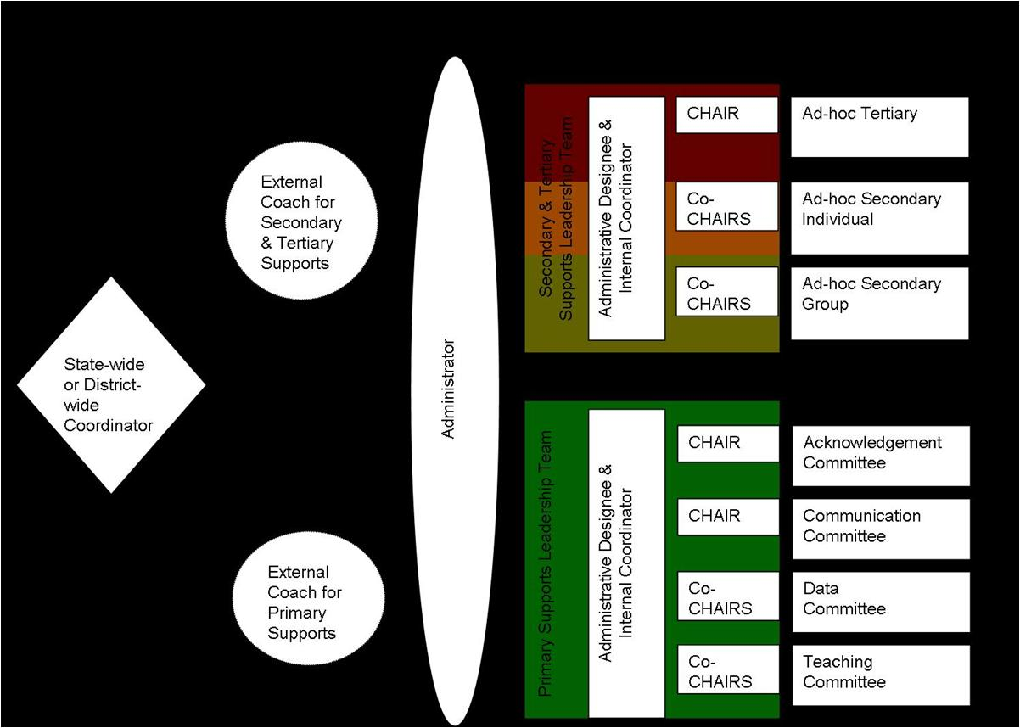

**Universal Support Positions**

|  |  |  |  |
| --- | --- | --- | --- |
| **Position** | **Description** | **Approximate Time Allocated for Position** | **Possible Individual to Fill this Position** |

|  |  |  |  |
| --- | --- | --- | --- |
| **District Administration** | | | |
| District Level Administrator (Director of Secondary Schools) | Makes administrative decisions that will support MTSS efforts at the building level (e.g. resources, supporting initiative expectations) and provides input on recommended building level approach | Available for quarterly check in meetings and ongoing communication when necessary |  |
| Building Level Administrator Representative | Provide building level perspective of feasibility of MTSS implementation | Available for quarterly check in meetings and ongoing communication when necessary |  |
| Curriculum Director | Support adoption of scientifically research based practices in core content academic areas | Available for quarterly check in meetings and ongoing communication when necessary |  |
| Director of Support Services | Provide support for implementation of scientifically research based practices for students at-risk or identified students with needs (e.g. receiving special education services) | Available for quarterly check in meetings and ongoing communication when necessary |  |
| Director of Discipline/School Safety | Provide support for implementation of research based practices for behavioral supports at the building level within the district | Available for quarterly check in meetings and ongoing communication when necessary |  |

|  |  |  |  |
| --- | --- | --- | --- |
| **District Based Staff** | | | |
| Districtwide Coordinator (3 Tier Prevention) | Oversees support and training of MTSS initiatives within a 3 Tier Prevention Model (e.g. RtI, PBIS, SEL) in district schools | Primary Responsibility |  |
| External Coach (primary supports) | Provide support and training with MTSS implementation, data analysis, and sustainability at the schoolwide level (e.g. support team meetings, organize data) | 10-20 hours a week |  |

|  |  |  |  |
| --- | --- | --- | --- |
| **Building Based Staff** | | | |
| School Liaison | Administrator who oversees functioning and makes administrative decision for all tiers of MTSS within the building (e.g. attends meetings, allocates resources) | 10 hours a month |  |
| Internal Coordinator (Primary Support Leader Team) | Internal staff who can lead staff, with support from the External Coach, in implementing MTSS schoolwide academics and behavior practices, run meetings and oversee sub-committees | 10 hours a month |  |
| Acknowledgement CHAIR | Lead the acknowledgement of student and staff behavior for schoolwide efforts, sub-committee in planning for celebrations and reinforcement systems within the school, meet with internal coordinator 2 times a month | 8 hours a month |  |
| Acknowledgement Sub-committee | Facilitate schoolwide acknowledgment activities, including design and implementation. | 4 hours a month |  |
| Data CHAIR (co-chairs) | Lead the data sub-committee in reviewing schoolwide academic and behavior data on a continuous basis to determine school needs and ongoing evaluation of implementation (e.g. ODRs, CBM). Prepares reports for schoolwide academic and behavior meetings, meets with internal coordinator 2 times a month | 8 hours a month per co-chair |  |
| Data Sub-committee | Facilitate schoolwide data activities, including collection and dissemination of relevant school data. | 4 hours a month |  |
| Teaching CHAIR (co-chairs) | Lead the teaching sub-committee in development of behavioral based lesson plans (e.g. lessons that teach expectations) around school needs (determined by data review) and support implementation of scientifically research based academic practices and curriculum (e.g. core curriculum review, Universal Design), meets with internal coordinator 2 times a month | 8 hours a month per co-chair |  |
| Teaching Sub-Committee | Facilitate schoolwide teaching activities, including the development of behavioral based lessons plans. | 4 hours a month |  |
| Communication CHAIR | Lead the communication sub-committee in development of plans and organization of initiative information to communicate to staff and students, meets with internal coordinator 2 times a month | 8 hours a month |  |
| Communication Sub-Committee | Facilitate schoolwide communication activities, including the development of plans and organization of relevant information to staff and students. | 4 hours a month |  |

**CAIRO PLAN**

**(Bolman & Deal, 2002)**

|  |  |  |  |  |  |
| --- | --- | --- | --- | --- | --- |
| **Task** | **Who is Consulted?** | **Who has ultimate Approval?** | **Who should be Informed?** | **Who is Responsible for carrying it out?** | **Who can be Out of the loop?** |
|  |  |  |  |  |  |
|  |  |  |  |  |  |
|  |  |  |  |  |  |
|  |  |  |  |  |  |
|  |  |  |  |  |  |
|  |  |  |  |  |  |

Action Plan Tuesday

Status: C= Complete, I=In progress, N=Not started

|  |  |  |  |
| --- | --- | --- | --- |
| **Task** | **Who** | **When** | Status |
| **Define outcomes of core instruction** | Whomever wants to help | At some point | ? |
| **Fix bad behaviors** | Mrs. B. | By tomorrow | Hurry! |

(contact Hank Bohanon [hbohano@luc.edu](mailto:hbohano@luc.edu))

**Bad Meeting Example**

Team Meeting Friday!!!

We will be discussing the following agenda items:

• Problems

• Ideas

Meeting notes from Friday

3:00 – Two team members were present

3:15 – Two present team members realized that time and place had not been announced

3:20 – Announcement made over loudspeaker

3:40 – All 8 team members present

3:45 – Team had an in-depth discussion about the problems with the raffle system. Comments included the following:

Mr. A. and Mr. B. feel that not enough teachers are using the raffle tickets, and that we should track somehow which ones are not.

Ms. C., Mr. D. and Ms. E. all feel that teachers should do this voluntarily and should not be punished for not using it. (This discussion went on until 4:05, with no resolution, when the next issue was raised).

Ms. F. commented that many times the raffles do not happen at all because there is no system for them. Ms. G. and Ms. H. offered the idea of setting up a schedule. The team debated the pros and cons of a schedule. Mr. A feels that a schedule makes things to rigid and is a problem if someone is out sick. Ms. D. agreed. Ms. G. and Ms. H. felt it would be better than the current situation. At 4:30, Ms. H. and Mr. A. began shouting and pointing fingers at each other, at which point Ms. G. and Mr. B. stood up and called for an end to the discussion since the meetings typically end at 4:15 and more business needed to be covered.

4:30 – Mr. B. brought up the issue of having a meeting facilitator. Ms. C. told a story about one staff member who ruined a team by becoming the leader and behaving like a tyrant. Ms. D. told a story similar to that of Ms. C.

4:45 – The team agreed to disagree for the time being and set another meeting for Monday, time and place TBA.

Adapted from reality Kira Hicks, Contact Hank Bohanon [hbohano@luc.edu](mailto:hbohano@luc.edu) or <http://www.hankbohanon.net>

**Effective Meetings**

**Reflection Activity**

1. Rate the health of their teams on each item

* 1. 5 positive things are going great
  2. 1 not at all and we need to work on this
* __Scheduling and communication
* __Creation and use of an agenda
* __Meeting begins and ends on-time
* __Keeping the meeting on track
* __Action plan/delegating tasks
* __Meeting Participation
* __Dissemination of meeting notes

For full self-assessment on teaming see <http://bit.ly/1dPG4LX>

**VTSS Team Meeting and Problem-Solving Action Planning Form**

|  |  |  |  |  |  |  |
| --- | --- | --- | --- | --- | --- | --- |
| **Today’s Meeting:** | Date: | Time: Click | Location: Click | Facilitator: Click | Minute Taker: Click | Data Analyst: Click |
| **Next Meeting:** | Date: | Time: Click | Location: Click | Facilitator: Click | Minute Taker: Click | Data Analyst: Click |

**Team Members (bold are present today):** Click here to enter text.

|  |  |  |  |  |
| --- | --- | --- | --- | --- |
| Today’s Agenda Items Next Meeting Agenda Items | | |  | Potential Problems Raised |
| 1. Celebrations 2. Click here to enter text. 3. Click here to enter text. |  | 1. Celebrations 2. Click here to enter text. 3. Click here to enter text. |  | 1. Click here to enter text. |

Administrative/General Information and Issues

| Information for Team, or Issue for Team to Address | Discussion/Decision/Task (if applicable) | Who? | By When? |
| --- | --- | --- | --- |
| Aligned Organizational Structure |  |  |  |
| Data Informed Decision-Making |  |  |  |
| Evidence Based Practices |  |  |  |
| Family, School and Community Partnerships |  |  |  |
| Monitoring Student Progress |  |  |  |
| Evaluation of Process |  |  |  |

|  |  |  |  |
| --- | --- | --- | --- |
| **Evaluation of Team Meeting** (Mark your ratings with an “X”) | Our Rating | | |
|  | Yes | So-So | No |
| 1. How well did we use our norms of collaboration in the meeting today? | 🞏 | 🞏 | 🞏 |
| 2. In general, did we do a good job of tracking whether we’re completing the tasks we agreed on at previous meetings? | 🞏 | 🞏 | 🞏 |
| 3. In general, have we done a good job of actually completing the tasks we agreed on at previous meetings? | 🞏 | 🞏 | 🞏 |
| 4. In general, are the completed tasks having the desired effects on student behavior? | 🞏 | 🞏 | 🞏 |
| If some of our ratings are “So-So” or “No,” what can we do to improve things? Click here to enter text. | | | |

**Virginia’s MTSS Action Planning Guide** [**http://www.doe.virginia.gov/instruction/virginia_tiered_system_supports/index.shtml**](http://www.doe.virginia.gov/instruction/virginia_tiered_system_supports/index.shtml)

**Activity:** Review “Early Stages for implementation”

Given your current setting –where are you in the Exploration Phase?

What might be some key experiences you can use to bring along your staff?

Link to article <http://ecommons.luc.edu/education_facpubs/17/>

**Reflection:** How will you encourage your teams to meet effectively?

Determine your next step.

Based on your team time discussion, list at least 1 action statement.

|  |  |  |
| --- | --- | --- |
| **WHAT NEEDS TO BE COMPLETED?** | **WHO** | **WHEN** |
| A. |  |  |
| B. |  |  |
| C. |  |  |
| D. |  |  |

**III. Enduring Understanding**: Be able to identify ways to work smarter and not harder

**Essential question:** What are effective methods to consolidate actions and activities and ensure all tasks are aligned with our mission.

**Connections to MBI Self-Assessment:**

* Process in place for efficient integration of MBI team with other teams/initiatives addressing behavior support and positive school climate
* Need for MBI team established and commitment gained among 80% or more of school staff
* New members are included on the team over time

**Activity:** Use the blank triangle on the following page to complete Activity:

Step 1: Identify all programs/initiatives/common practices by tier

Tier I- How do you support all children? Core Curriculum- “everyone gets”

Tier II, III. How do you support students who need more support? How do you build on the foundation so that all Tier II, III activities are a natural extension of core curriculum?

Other considerations:

Can you identify outcome for each practice? How do you measure effectiveness?(Staff performance) How do monitor progress? (student impact) How do you support teachers? (staff support)How are they linked to School Improvement? (integrated approach)

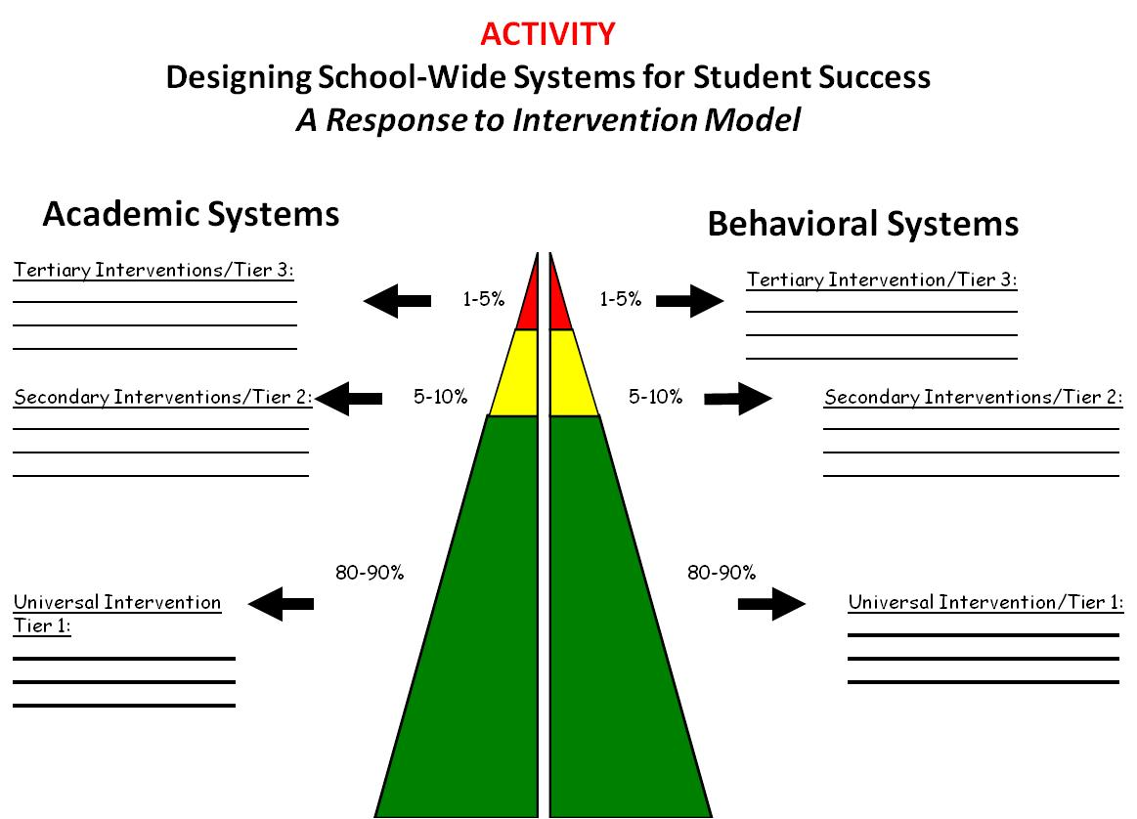

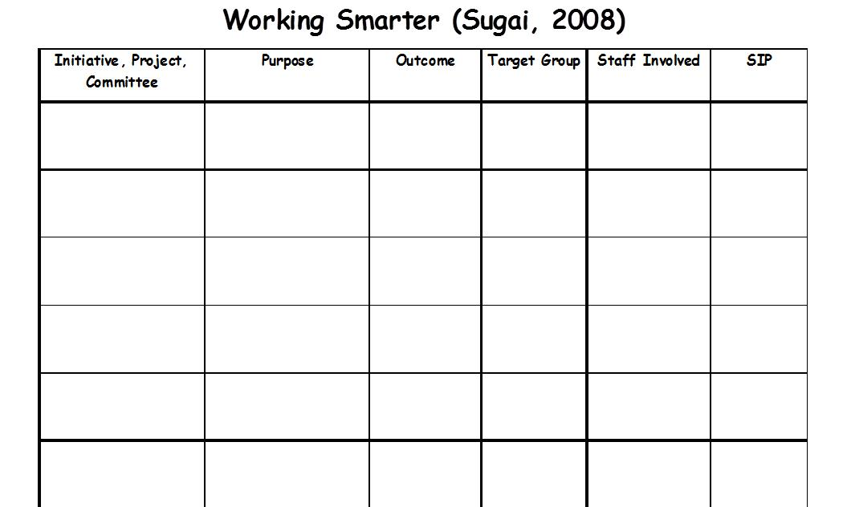

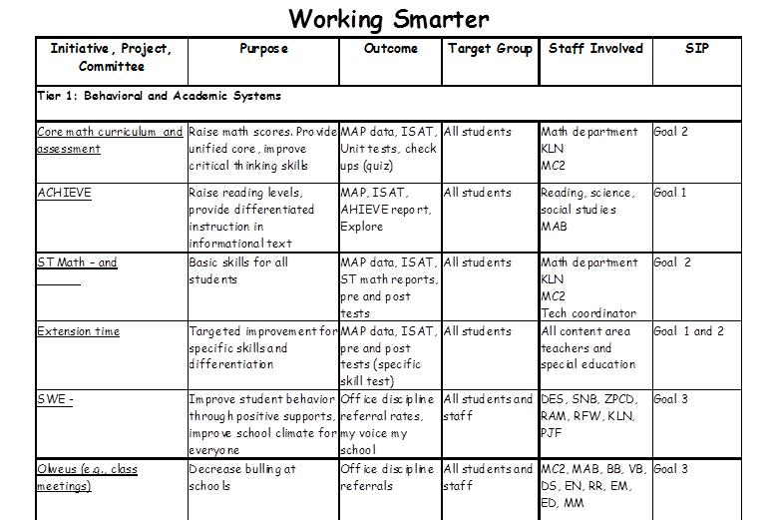

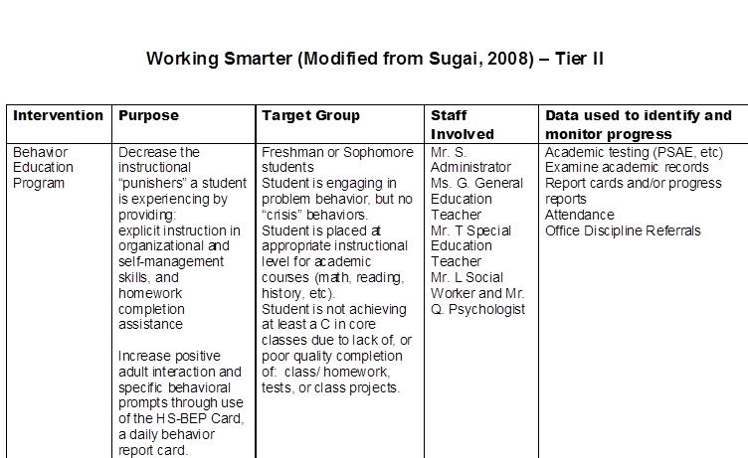

Link to Behavior Education Program: <http://miblsi.cenmi.org/LinkClick.aspx?fileticket=XqRfz3O9AFo%3d&tabid=1855>

Area: **Secondary Pathway – example provided by Marla Dewhirst <marla.r.dewhirst@gmail.com>**

|  |  |  |  |  |
| --- | --- | --- | --- | --- |
| **Criteria for Placement:** | Failing one or more classes (F)  Less than 2.0 GPA  2 credits behind  10% or more absences per year  4 ODR’s per year or 2 per semester  Meets criteria in any area listed above | One or more D’s in any class  2.0 to 2.49 GPA  One credit behind  5% to 9% absences per year  3 ODR’s per year  Meets criteria in any area listed above | C’s or better in all classes  2.5 to 3.75 GPA  Credits will move to next grade level  4% or less absences per year  2 or fewer ODR’s per year  Meets all criteria listed above | 3.75 or higher GPA  95th Percentile on one or more areas  Credits will move to next level  4% or less absences per year  2 or fewer ODR’s per year |

|  |  |  |  |  |  |  |  |  |  |
| --- | --- | --- | --- | --- | --- | --- | --- | --- | --- |
|  | **Intensive** | | | **Strategic** | | | **Benchmark** | | **Advanced** |
| **Instructional Focus:** | Explicit Instruction of Targeted Skills | | | Targeted Skills | | | Universal Expectations for Academics, Study Skills, Behavior and Social Skills | | Extended Learning |
|  | **Academic** | **Behavior** | | **Academic** | | **Behavior** | **Academic** | **Behavior** | **Academic** |
| **Interventions & Intervention**  **Strategies:** | -System 44  -PreAlgebra Select  -Alternative Placement  -Special Education  -Check & Connect  -SPSC Determined Interventions | - E-Net  -Alternative Placement  -CSCT  -Check & Connect  -Home Connections  -Attendance Buy-Back  -SPSC Determined Interventions | | -Mentoring  -Check & Connect  -Check-In Check-Out (CICO)  -ASIST  -Read 180 (Reading Lab)  -Credit Recovery  -PAL  -Applied courses (Biology & English)  -Scheduling  -SBOT/CSCT | | -Mentoring  -Check & Connect  -Check-In Check-Out (CICO)  -Transitions  -SBOT/CSCT  -Home Visits  -Attendance SPSC | -Differentiated Instruction/Co-Teaching  -Star Math/Ed Ready  -Parent Contacts  -Small Learning Communities  -MT Digital Academy  -Great Eight | -Teaching the Capital Code Schoolwide  -Parent Contacts  -Home Visits  -Small Learning Communities  -Great Eight | -Honors Classes in addition to Standard Classes  -AP or IB |
| **Delivery:** | -Student Coordinator  -School Psychologist/School Counselor  -Resource Teachers & Staff  -CSCT & SBOT Staff | | | -Student Coordinator  -School Counselor  -CICO Mentors  -Classroom Teacher | | | All Staff | All Staff | Assigned Staff |
| **Time in delivery:** | >60+ min./week differs from reg. class schedule | | | Approx. 30 to 60 min./week in addition to regular class schedule | | | Standard class Schedule | Standard Class Schedule | Select Schedule |
| **Progess Monitoring:** | -Program Assessments  -Grades  -Weekly AC Checks  -SPSC Review | | -SWIS  -Check & Connect Data  -SPSC Review | -Program Assessments  -Grades  -Bi-Monthly AC Checks | - SWIS  -CICO Data  -SSA Data (Student Self-Assessment Data) | | -Grades  -GPA  -Credits | -Attendance Data  -ODR’s | -Rubrics, Grades & Projects |

**You Gotta Love It!**

**Criteria for selecting Practices**

**Activity:**

Create criteria to select practices to address your school improvement plan. You need to select three criterions that the practice “must have”, and three that it would be “good to have.” In order to select/support a practice, it needs to meet the standard for all three “must haves” and at least two “good to have.”

I have included some sample criterion. Some of taken from George Sugai’s working smarter framework.

**Possible criterion:**

Use data to monitor their efforts (I would argue as a must have)

Are related to the school improvement plan (I would argue as a must have)

Are based on evidence the approach can work in our setting (I would argue as a must have)

Are politically important

Can be implemented efficiently by teachers

Includes training for staff

Provides access to some type of coaching for staff

Other

1. List out your criteria for selecting practices below (you can create your own) (three “must have”, and three “good to have”)

|  |  |
| --- | --- |
| Must have | Good to have |
| 1.  2.  3. | 1.  2.  3. |

2. List one schoolwide practice you are implementing here:

3. _________How many “must have” criterion does it meet?

_________ How many “good to have” criterion does it meet?

Adapted from McKeon, G. (2014). *Essentialism: The disciplined pursuit of less.* Crown Business

**Reflection:** How will you continue to map and organize? How do supports/activities change across the year?

*Consider what communication structures for sharing information and data you have in place now and discuss what opportunities you haven’t explored yet. Record your team’s discussions.*

Determine your next step.

Based on your team time discussion, list at least 2 action statements.

|  |  |  |
| --- | --- | --- |
| **WHAT NEEDS TO BE COMPLETED?** | **WHO** | **WHEN** |
| A. |  |  |
| B. |  |  |
| C. |  |  |
| D. |  |  |

**IV. Organizing multiple data sources**

**Enduring Understanding:** How can you use data to plan for interventions – at the beginning of the year and on-going?

**Essential Questions:** How can teams convert data to a plan of action based on fidelity and outcomes?

**Connections to MBI Self-Assessment:**

* A school data collection system is in place
* Data is collected to determine site needs and status
* Data is summarized and analyzed
* Data is used for decision-making—creating action plans and interventions
* Data collection system allows for on-going evaluation and decision making
* Staff receives feedback on efficacy of implementation of MBI process/practices
* Multiple data sources are used to identify students who are not successful with Universal strategies alone (e.g. office referrals, teacher referral)

**Using Schoolwide Data (Dowdy, Ritchey, and Kamphaus, 2010):**

**Reflective question: Based on what works for using schoolwide data, where are you? What are your action steps?**

1. Establishing a team to guide planning and implementation

2. Identifying the purpose and specific goals for screening within a school settings (SEL - PLC 1)

3. Examining the utility of screening tools in light of the purposes of screening (PLC 2)

4. Selecting screening tools that are linked to goals (PLC 2)

5. Identifying available resources to provide interventions in the school settings based on screening outcomes (PLC 3)

6. Developing a specific timeline and process for data collection (e.g., action plan) (PLC 3)

7. Sharing the results with stakeholders (e.g., teachers, schools, and individual students), studying and reporting data to district level personnel. (PLC 3)

**Sample Dashboard for Schoolwide Review**

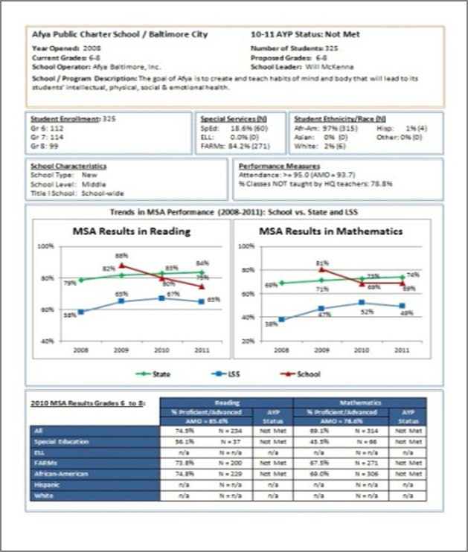

**(From https://www.relmidatlantic.org/forums/creating-and-using-automated-data-dashboards-0)**



**Creating and Using Automated Dashboards** Presented by Rosemarie O’Conner, Ph.D.

**Step 1: Make a model report in Word**

• Create a model of what you want your “final” copy to look like and populate your charts and tables with fictional data

**Step 2: Add bookmarks to your model report**

a) Print your model report and circle or highlight every single detail that needs to change from one report to another – words, numbers, tables, charts, etc.

b) Add bookmarks in Word a. Make your bookmarks visible to keep yourself organized: Word Options → Advanced → Show document contents → Show bookmarks

c) Make a list of every single one of the bookmarks you just created

d) Save this Word document with the bookmarks as a .dotx file (This is called a Word “template”)

**Step 3: Organize the data in Excel**

1. Make a “setup” sheet with 3 columns:

o Column of dashboard data – the column where the datum is going to come from

o Bookmark name

o Short description of the bookmark to keep yourself organized

b) Make a “data” sheet o Transpose the data from the “Setup” into the first 3 rows of the “Data” sheet

o Fill in your data! ▪ Use the =text() function to convert all numbers to text

1. Make your “charts” sheet

o Generate all the charts beforehand (and edit them individually before finalizing the report)

o Each chart has a name, and you have to record that name

**Step 4: Run the code**

a) Code info sheet o Add the name of the template you created

o Add the name of the folder where you want the completed reports to be stored

o Add the row number where the actual data begin

b) Run the macro

(From <https://www.relmidatlantic.org/forums/creating-and-using-automated-data-dashboards-0>)

**Installation and initial implementation: Using data and preparing for your core**

|  |  |
| --- | --- |
|  |  |

|  |  |
| --- | --- |
|  |  |

If these were your data, how would you respond?

Additional Resources

My Voice Survey<http://svsurveys.corwin.com>

My favorite website for using screening data <http://www.ci3t.org>

My favorite book on using screening data – Kathleen Lane *Systematic Screenings of Behavior to Support Instruction: From Preschool to High School*

**Data Next Steps**

**What data are connected to your universal outcomes?**

(Examples: Who is not responding to universal support according to specific criteria: 3 or more major office discipline referrals within a 4- week period; 5 or more unexcused absences in a quarter; 2 or more class failures in a quarter; 5 to 10 nurse visits in a 2-week period; 6 tardies to a class in a quarter; and/or, student failed to complete a minimum of 50% of class assignments in a 2-week period after initiating parent contact and student conferences; Malloy, J., Bohanon, H., Francoeur, K. (In Submission).)

**Where are they?**

**To get these data into a format for decision making:**

Who needs to contacted:

Who needs to approve:

Who needs to be informed:

Who is responsible:

Who can be out of the loop for now:

**V. Effective classroom instructional models based on universal supports**

**Enduring Understanding:** Be able to identify the components of engaging environments that prevent and address problem behavior for students

**Essential Questions:**  What are the components of effective school environments? How do these components connect with an effective instructional model?

**VT School Climate**

Domain 1 Safety:Behavioral Expectations, Sense of Social and Emotional Security; Domain 2 Physical Environment: School Connectedness & Community Engagement; Domain 3 Teaching and Learning: Social Skills Development, Student Engagement and Self Direction; Domain 4 Interpersonal Relationships: Social Supports for Students

**Connections to MBI Self-Assessment:**

* 3-5 positively stated guidelines with corresponding clearly defined expected behaviors are developed for ALL school settings
* Formal lesson plans or other strategies designed/written to teach guidelines, procedures and routines for ALL settings
* School-wide matrix developed
* Guidelines and expected behaviors are directly taught/reviewed throughout the school year in all classrooms and all settings
* Opportunities are provided to practice expected behaviors, routines and procedures
* Staff supervision increased in common areas
* Staff understands key staff behaviors that affect student management in common areas
* Students are acknowledged with specific feedback when they display the expected behavior
* Student errors are corrected in a positive/instructional manner
* Staff and students understand and use problem-solving strategies/steps during teachable moments
* System is in place to publicly acknowledge/reward students who demonstrate school-wide expectations
* Staff and administration agree on what problems are office managed and what problems are staff managed
* A continuum of consequences exist to address behavioral offences
* Strategies implemented to increase positive interactions between staff and students
* Effective classroom management strategies used in 80% or more of classrooms

**Supportive Environments Quiz**

With the following statements, decide who was the possible author (e.g., elementary school administrator, middle teacher, high school teacher, other).

1. We cheer people on all the time..We celebrate everything! Although we do have some formal celebrations, a lot of them are informal, spontaneous celebrations that cost little or no money.
2. We catch people doing things right and accentuate the positive by praising them.
3. [After problem] I watch him or her closely so that, as soon as possible, I can catch the person doing something right.
4. People listen to you because they trust you, not just because of your authority.
5. Culture defines what “Doing the Right Thing” means in a group, it makes dealing with expected behavior “not personal.”
6. Our core values include: Pursue Growth and Learning, Be Passionate and Determined, Be Humble

**LESSON PLAN OVERVIEW**

**BIOLOGY**

**Week of September 1, Periods 1,2,4,5,7**

**By BK**

Themes: Welcome students;

Begin to set climate of class (i.e. a climate of safety and learning);

Introductions and overview of class, expectations and routines;

General introduction to science and to “science in the news”.

**Monday, 9-01**

No School - Labor Day Holiday

**Tuesday, 9-02 (modified schedule)**

1. Welcomes students.

2. Introductions - introduce self ; have students introduce the student next to them by first interviewing him/her (using prompts listed on transparency) and then introducing them to the class. *(transparency: listing interview questions*)

3. Present a general overview of the class. (refer to *transparency*).

4. Explain what supplies students are expected to bring with them daily. *(transparency: listing supplies).*

*5.* Distribute and have students complete the *student profile forms.*

5. Sign programs

{materials: transparencies; student profile form; programs}

**Wednesday, 9-03 (advisory schedule)**

1. Welcome any new students. Sign programs.

2. *Bell ringer*: have students complete a chart *[*refer to *transparency* which lists the 4 school wide areas of expectations: (1) be respectful; (2) be academically engaged; (3) be responsible; and (4) be caring.] Ask students to list the tings they can do to meet each of these areas. Then ask students to list the expectations they will have of me as teacher in each of the areas.

3. Ask students to present their lists and compile one master list for class (on easel paper)

4. Distribute and review list of class rules.

5. If time allows: Prompt students to brainstorm current worldwide science related topics. List on white paper.

Discuss each item with students prompting them to tell everything they know about the topic.

Emphasize how important science is to our every day life.

{materials: transparencies; white easel paper}

**Thursday, 9-04**

1. If # 5 from yesterday was not completed have students make a list of science related news topics as *bell ringer*.

2. Relate to theme of science in the news, show video of various news clips regarding major current science related issues occurring throughout the world. Stop and start video prompting discussion of each topic. Relate to list completed by students.

(*materials: video, vcr, TV, white sheet from yesterday)*

**Friday, 9-05**

1. Distribute Biology pre-test. Explain purpose. Have students take test. {handout pre-test}

**BIOLOGY SYLLABUS**

**Class Taught by Mr. K**

**September,**

**Course Description**

Biology is the study of living things. Scientists estimate that there are more than 12 million different species of organisms living on Earth today. These living organisms range in size from tiny microscopic bacteria to huge blue whales and towering redwood trees. Although they differ greatly in where and how they live, all living things share certain characteristics that make them different from nonliving things. These characteristics include the ability to reproduce, to grow, to develop, to use energy, and to respond and adapt to changes in the environment.

**Course Objectives:**

By the end of the school year you will be able to demonstrate a good understanding of the principles, processes and vocabulary related to the following areas:

1. Important life processes;
2. Scientific inquiry and investigation, including the scientific method;
3. The cell, including cell theory, cycle, structure, processes, growth and division;
4. Biochemistry;
5. Ecology;
6. Energy processes, including photosynthesis, ATP and cellular respiration;
7. DNA and Genetics;
8. Reproduction;
9. Classification;
10. Evolution;
11. Other current science, research and related issues;

**Required Texts, Materials, and Supplies**

Text: BIOLOGY, The Web of Life By Scott, Foresman, Addison Wesley

Materials and Supplies

(1) Notebook (3 ring binder);

(2) Pens, paper, pencils;

(3) Other items supplied by the school, I.e. colored pencils, dividers, markers, construction paper, rulers, microscopes, videos, lab materials and supplies, pictures, newspapers, journals, magazines and other scientific publications

**Class Format**

*Bell ringers *Lecture *Demonstration

*Individual, pair and group work *Reading *Written class assignments

*Note taking *Homework *Lab activities

*Reports (written and oral) *Presentations *Vocabulary work

*Science notebook *Interactive dialogue, discussion, debate

*Tests and quizzes *Research paper *Extra credit assignments

As indicated by the above list, the class format will emphasize and incorporate reading, writing and higher order thinking skills.

**Classroom Rules and Expectations You Will:**

1. Follow the Uniform Discipline Code;

2. Follow the classroom expectations (see attached lists)

3. Maintain good attendance; **[Unexcused absences WILL LOWER YOUR GRADE**]

|  |  |
| --- | --- |
| **# of days absent**  **\*from 9/2/03 to 1/30/04** | **Highest possible grade for**  **Semester One** |
| **Less than 9** | **A** |
| **9** | **B** |
| **10 - 13** | **C** |
| **14 - 17** | **D** |
| **18** | **F** |
| *the same policy applies to Semester 2, just change the | dates from 2/2/04 to 6/22/04 |

**Grades**

**Grades will be determined by the percentage of total points accumulated. Grades will be given as follows:**

90 - 100 A

80 - 89 B

70 - 79 C

60 - 69 D

Below 60 F

|  |  |  |
| --- | --- | --- |
| **Notebook**  **(10% of grade)** | **Performance Points**  **(25% of grade)** | **Academic Points**  **(65% of grade)** |
| Organization of all work | On time for class  Prepared for class | Tests  Quizzes |
| Neatness of papers | Behavior | Activities and projects |
| Ownership of notebook:  Evidence of individuality | Participating in class discussions and assignments | Class work and homework |

* There will be no exceptions to the grading policy. Tardiness, cutting and inappropriate behavior will have a big effect on your grade.

* Chapter tests and quizzes: material will come primarily from assigned readings, lecture notes, lab work, and other assignments as announced.

* Assignments MUST be legible or they will be returned without a grade.

* Semester tests: will be comprehensive.

* Make-up tests: For excused absences only , must be taken within three days of the student’s return to school.

* Late work: Work that is late, due to an excused absence or other approved reason, will be accepted within one week of the due date. Grade may be lowered one step. NOTE: If absent, it is the **student’s responsibility** to find out what he or she has missed .

**\*\*\*\*\*\*\*\*\*\*\*\*\*\*\*\*\*\*\*\*\*\*\*\*\*\*\*\*\*\*\*\*\*\*\*\*\*\*\*\*\*\*\*\*\*\*\*\*\*\*\*\*\*\*\*\*\*\*\*\*\*\*\*\*\*\*\*\*\*\*\*\*\*\*\*\*\*\*\*\*\*\*\*\*\***

I have read the syllabus for Mr. K’s class. I understand the content of the syllabus and agree to abide by the rules, expectations and other items outlined in it.

______________________________ ______________ _______

Signature Date Period

**CLASS EXPECTATIONS**

**As prepared and listed by students on in**

**Mr. K’s BIOLOGY CLASSES**

**\*\*\*\*\*\*\*\*\*\*\*\*\*\*\*\*\*\*\*\*\*\*\*\*\*\*\*\*\*\*\*\*\*\*\*\*\*\*\*\*\*\*\*\*\*\*\*\*\*\*\*\*\*\*\*\*\*\*\*\*\*\*\*\*\*\*\*\*\*\*\*\*\*\*\*\*\*\*\*\*\*\*\*\*\*\*\*\*\*\*\*\*\*\*\*\*\*\*\*\***

**RESPECT**

TREAT OTHERS THE WAY YOU WANT TO BE TREATED

Be polite to each other:

Don’t maker fun of other people

Listen to others

Respect other people’s opinions Respect other people’s belongings Don’t interrupt others Enter and leave the room without pushing or yelling

Raise your hand before talking

Follow rules

Do not disturb the class

Use proper language - No profanity - It’s not just what you say but how you say it (tone of voice, inflection)

No rude nonverbal body language - I.e. rolling eyes; slouching; loud sighing

ATTITUDE

**ACADEMICALLY ENGAGED**

COME TO CLASS WITH CONFIDENCE

Work hard

Do your best

Come prepared for class:

Bring assigned completed work

Bring needed supplies

Complete all assignments and do it on time

Be organized

Take notes

Ask questions

Listen

Participate in activities, discussions

Work with and help others

Pay attention

Come on time

Use the library

Discuss and debate

Learn how to communicate

Study

Raise your hand before talking

ATTITUDE

**RESPONSIBILITY**

TAKE RESPONSIBILITY FOR YOUR ACTIONS

Do your best

Show respect to others

Wear ID (visible)

Follow dress standard

Be on time

Listen

Listen before acting

Copy down assignments

Complete assignments

Come prepared for class

Keep track of things

Take care of books, supplies, classroom

Return supplies and other borrowed items

Help others

Attitude

BE HONEST

**TEACHER**

BE A ROLE MODEL - SET A GOOD EXAMPLE  
 Be polite

Be on time

Come prepared with completed lesson plan

Give meaningful work

Respect students

Respect the opinion of students

Be fair to all students

Treat all students equally (don’t play favorites)

Pay attention to students

Make eye contact with students

Listen to students

Listen to suggestions

Help students

Answer questions

Don’t use put downs

Don’t use profanity

Stay calm; don’t yell; control anger

Give advance notice of assignments and tests

Grade papers and tests on time

Grade “right” (fairly)

Watch body language

Maintain a clean classroom

Remember that “things go both ways”

Treat students as young adults

ATTITUDE

**BUILDING EXPECTATIONS**

**Sample Lesson Plan**

**Objective:** Students will be able to identify and demonstrate respectful behaviors in common areas when presented with a role play situation.

**Expectation:** Be Respectful

**Location:**  When talking with adults in hallways, classrooms, and assemblies.

**Activity:** Role play either with students or staff

**Why this is important:** Ask *“Why is being respectful to adults important?”*

(Sample responses include: People treat you the way you treat them, its nice, everyone is happier)

**Negative Example:**

Ask*“What does it look like to be disrespectful to adults?”*

(Sample responses include: yelling back, screaming, cursing, continue to talk)

**Positive Example:**

Ask *“What does it look like to be respectful to adults?”*

(Sample responses include: listening while others talk, using inside voice,

**Practice:**

Students practice negative example first then positive. Tell the students,

Say  *“We are going to practice the wrong and the right way to ___________.” First, you are going to show us what being disrespectful looks like in ______________. Then, we are going to practice it the right way.”*

Say *“Remember not to do anything that will get you sent to the office or sent home. Also, remember when I raise my hand you are to stop what you are doing! When I raise my hand what are you to do?”*

**How will you know they have learned the skill?**

*“OK, great job! We will be looking for these sorts of behaviors in the fall. If you follow these expectations, you will have a much better experience at Senn. Thank you and good night Las Vegas.”*

**Next Steps:** Practice or discuss other situations *“what should you do if asked for your ID in the hall?”*

**BUILDING EXPECTATIONS**

**Sample Lesson Plan**

**Objective:**

**Expectation:**

**Location:**

**Activity:**

**Why this is important:**

**Negative Example:**

**Positive Example:**

**Practice:** Students practice negative example first then positive. Tell the students, “Remember not to do anything that will get you sent to the office. Also, remember when I raise my hand you are to stop what you are doing! When I raise my hand what are you to do?”

**How will you know they have learned the skill?**

(short term and long term)?

**Next Steps:**

**Checklist for teaching expectations**

|  |  |
| --- | --- |
| **Activity for teaching ___________**  **(list the expectation being taught)** | **Yes= 2 Good Start = 1 No = 0**  **Comment for additional practice** |
| Was the schoolwide expectation explicitly stated? |  |
| Was the location where the behavior is to be carried out identified? |  |
| Was the teaching method clear (e.g. discussion, role play) |  |
| Was a prompt given to discuss why this expectation was important? |  |
| Were students asked for negative examples of the expectation? |  |
| Were students asked for positive examples of the expectation? |  |
| Were the students allowed practice the negative, then the positive behavior? |  |
| Did the teacher pre-teach prompts (e.g., when I raise my hand, stop yelling), to stop inappropriate role play (e.g., show what … does not look like) and were limits of behavior set? |  |
| Did the teacher pre-teach limits for the negative role play (e.g., remember not to do anything that will get your thrown out of class)? |  |
| Were the students provided with feedback about their performance and perhaps additional practice in another situation? |  |

**Total Points:_____________________ Teacher’s Name:________________**

**Percentage:______________________ PBS Consultant:________________**

**Teacher has reached a proficiency level of 90% or better ____________**

**Yes/No**

**Speaking and Listening Common Core**

Comprehension and Collaboration

SL.K.1. Participate in collaborative conversations with diverse partners about kindergarten topics and texts with peers and adults in small and larger groups.

Follow agreed-upon rules for discussions (e.g., listening to others and taking turns speaking about the topics and texts under discussion).

Continue a conversation through multiple exchanges.

SL.K.2. Confirm understanding of a text read aloud or information presented orally or through other media by asking and answering questions about key details and requesting clarification if something is not understood.

**SL.K.3. Ask and answer questions in order to seek help, get information, or clarify something that is not understood.**

Presentation of Knowledge and Ideas

SL.K.4. Describe familiar people, places, things, and events and, with prompting and support, provide additional detail.

SL.K.5. Add drawings or other visual displays to descriptions as desired to provide additional detail.

**SL.K.6. Speak audibly and express thoughts, feelings, and ideas clearly**

**Example Matrix:** First Day of School Laptop Roll Out and PBIS Lessons for Computer and Technology For Grades 7-12

|  |  |  |  |
| --- | --- | --- | --- |
| ***Laptops/Desktops*** | | | |
| ***SAFE*** | ***RESPECTFUL*** | ***RESPONSIBLE*** | ***STAFF*** |
| * Carry laptop with cover closed * Use a padded carrying case to take the laptop home * No food or drink | * Check out the laptop so others know you have it * Stay only in your files keeping others’ files safe * Hard drive passwords are off limits | * Keep backgrounds, screensavers, or any settings in original settings * If there is a problem with laptop report it * Personal laptops used only with permission | * Monitor, supervise, and teach appropriate behavior and safety |

Expectations of laptop care were reviewed with technology coordinator and superintendent on the first of school. Grades 7-12 were accompanied by their sponsors at different stations that covered internet, cellphone, and technology safety expectations. All staff was involved in teaching the internet safety lessons.

|  |  |  |  |  |  |
| --- | --- | --- | --- | --- | --- |
|  | Laptop Checkout | Oops I broadcast it over the Internet…. | Overexposed | College Bound | Private Today, Public Tomorrow |
| 10:00 to 10:20 | 11th-12th Gr | 9th-10th Gr | 7th-8th Gr |  |  |
| 10:25 to 10:45 |  | 11th-12th Gr | 9th-10th Gr | 7th-8th Gr |  |
| 10:50 to 11:10 |  |  | 11th-12th Gr | 9th-10th Gr | 7th-8th Gr |

Ona Ebsen

School Counselor

West Boyd Public School

www.westboyd.com

Spencer, NE 68777

402.589.1333

Fax: 402.589.1142

**Student Engagement: Two ways to increase student engagement**

# (by: Hank Bohanon - see hankbohanon.net)

We are looking for ways to make things work together. A great deal of focus in school is on integrating behavior and academic support. One area that naturally bridges both is student engagement or school connection. Researchers have found relationships between academic improvement and student connections (see for really good article on this <http://eric.ed.gov/?id=EJ1007218>).

According to van Uden and colleagues, engaging students is about the relevancy of the content, the way it is delivered, and other overall climate of the class. I came across their study that included the voice of students related to this topic. These were from students at both K-12 and university levels. I thought their insights were very useful.

Two ways create engagement:

1. Simply asking a student about how their day was going was a very effective approach to engagement. One student said the teacher only had to say a few works, but they felt like the teacher cared and understood them..which was motivating..

1. Asking if you can help and give feedback. Several students said that just asking if they needed help or providing feedback about performance was “support.”

Two ways to create disengagement:

1. Asking detailed questions about the students’ life was not engaging. Many of the students said they did not want to be friends with their teachers. They just wanted the teacher to understand their perspective and if they were going through something that might require some accommodation. I once heard a teacher talk about sharing her early drug use with her students as a way to connect (not how she recovered from this), not a good plan…too much information (TMI) is not good for anyone..

1. Just handing out the work was disengaging. The students said a real turn off occurred when teachers just handed out the work without really covering it (e.g., describing, modeling). See Ferris Buellers Day Offfor more details on how to create disengagement (<https://www.youtube.com/watch?v=uhiCFdWeQfA>)

Charge and question  
To these students, engagement was not about therapy (although there is a place for therapy). It was about taking short amounts of time to ask how they are doing and asking if they needed help. There is certainly more to engagement, but this is a very efficient approach. This article if full of great quotes from students and discussion points. I would recommend it for a professional learning community or other book club. What examples you have seen of engaging students in really simple ways? The article should be available at:<http://www.sciencedirect.com/science/article/pii/S0742051X13001352>

**Student Engagement**

Very good resource for research around literacy and student engagement (Click on Icon)



**Also…**



# Learning Together About Engaging Text Discussion

**Purpose** Trainers, coaches, and expert teachers are encouraged to use this tool to provide in-service training on facilitating text discussion. During this session, teachers will work in the larger group and in small groups to deepen their understanding of instructional strategies and practices.

**Materials** Laptop and projector

**Media** [*Talking About Text: Discussion-Based Approaches to Reading Instruction*](http://wested.mediacore.tv/media/talking-about-text-discussion-based-approaches-to)*.* Watch this multimedia presentation to learn about important features of extended discussions about text. (5:51)  
  
[*Engaging Adolescents in Discussions About Text*](http://wested.mediacore.tv/media/engaging-adolescents-in-discussions-about-text)*.* Watch this expert interview with Dr. Janice Dole to learn about how teachers can use engaging text discussion to facilitate reading comprehension. (5:28)

Topic Adolescent Literacy

Practice Engaging Text Discussion

## Learning Together About Engaging Text Discussion

1. Watch the multimedia presentation, *Using Text Discussions to Engage Students and Improve Comprehension* and the expert interview, *Engaging Adolescents in Discussions About Text*. Lead a discussion to clarify the team’s understanding about engaging text discussions. Ask them to reflect on these questions:
   * Why is it important to provide opportunities for adolescents to discuss text?
   * What are some key features of effective, extended discussions?
   * What should teachers consider when selecting a text for a discussion?
   * What are some of the roadblocks to implementing this practice? What are some ways to address these roadblocks in your classroom?
   * What kinds of tools, materials, or training would you need to incorporate more text discussion into your classroom?
2. Discuss as a group: What can teachers do to create a classroom environment that supports classroom discussion?  
     
   Option: Teachers may discuss the question in small groups and draw a visual diagram of a classroom environment that supports discussion.   
     
   Whole group or small group discussion topics may include the following:
   * Posing authentic and provocative questions for discussion
   * Establishing classroom norms for discussions
   * Creating a safe space for practicing speaking and listening
   * Modeling and practicing discussion roles
   * Providing prompts for participation (e.g., sentence starters)
   * Providing tools to organize discussions (e.g., graphic organizers)
   * Discussion aids posted on classroom walls
   * Physical set-up of classroom
3. Fishbowl exercise:   
     
   To the trainer: Bring in a short text and provocative discussion question for a fishbowl exercise. A group of 5 or 6 teachers is seated in a circle in the middle of the room, surrounded by observers. The group in the center is asked to read the text and respond to the question. The observing group takes notes.  
     
   Option: You may take this as an opportunity to try out an activity structure like reciprocal teaching or literature circles, or simply have a free-form discussion.  
     
   Lead a discussion after the fishbowl activity about what was observed. The questions below can serve as prompts for observers’ note-taking during the discussion or for the debrief after the discussion:
   * What did you notice about body language and non-verbal behavior?
   * What did you notice about how people expressed an opinion?
   * What did you notice about the language or manner with which people agreed or disagreed?
   * (If using roles) What did you notice about how each person carried out their role?
   * How effective were the text selection and discussion question?
   * What skills or strategies did you notice the teachers using that your students haven’t mastered yet?

As a wrap-up, have teachers discuss how they might conduct a fishbowl activity in their own classrooms and how they would modify the activity for their own use.

**Acknowledging Students for Good Behaviors**

* Try to use a 4 to 1 ratio of positive to corrective comments in the classroom
* Be specific : “Thank you for being respectful and handing me your ID when I asked for it”
* Recognize students immediately after a good behavior
* Be genuine: Convey sincerity with tone of voice and body language, message, and choice of behavior to acknowledge (avoid patronizing students)
* Use vicarious reinforcement: acknowledge a student who is meeting your expectation when others are not: “I really appreciate how productive group one is being right now, you all have your books open and are taking notes”
* Make the activity relevant: If the content of an academic activity is meaningful and interesting for students, it is rewarding for them to behave well and participate. For example, for math class, allowing them to complete word problems to figure out how to save money for a video game system (Xbox, Playstation, etc.)

**Pop quiz**: What do you have available to you that would help you reinforce students in a specific, immediate, genuine way? (Hint: Think School Store)

Types of acknowledgement:

Immediate/Frequent:

Intermediate (weekly?) – homework example

Large scale, school sprit oriented (school picnic?)

|  |  |  |
| --- | --- | --- |
| **snapshot.GIF Snapshot: Continuum of Strategies to**  **Encourage Appropriate Behavior**  **Benchmarks of Quality 25-32** | | |
| *Practice: Behavior Specific Praise Statements (BSPS) Ratio 4:1* | | |
| ***Research*:**  The research supports the use of behavior specific praise statements to:   * teach new behaviors and support maintenance of acquired behaviors (Mesa, Lewis-Palmer, & Reinke, 2005) * to increase on-task behavior (Fullerton, Conroy, & Correa, 2009) * to decrease problem behavior (Hawkins, & Heflin, 2010; Lampi, Fenty, & Beaunae, 2005; Lane, Kalberg, Bruhn, Mahoney, & Driscoll, 2008; Mesa, Lewis-Palmer, & Reinke, 2005; Stormont, Covington Smith, & Lewis, 2007; Sutherland, Wehby, & Copeland, 2000) * provide increased opportunities for building positive relationships with students * provide support to students with the most challenging behavior, needing targeted and/or intensive supports, through more frequent behavior specific praise statements delivered contingently for appropriate behavior coupled with less frequent reprimands for inappropriate behavior. Students with the most challenging behavior typically do not receive access to even the average rates of praise that students without challenging behavior receive (Lewis, Hudson, Richter, & Johnson, 2004) | | |
| ***What is it?***  A behavior specific praise statement is verbal/written feedback that is *descriptive*, *specific*, and delivered *contingent* upon student demonstration of expected behavior (Gable, Hester, Rock, & Hughes, 2009; Hawkins & Hefflin, 2010) | ***Effective Praise***   * “Excellent job listening and following directions the first time.” * “Your eyes are on me and your mouth is quiet. Thank you for being ready to learn.” * "Way to go! You asked for help and followed the steps to complete your math work before the end of class!” * "Thank you for being on time this morning, that's very responsible." | ***Less Effective***   * "Good job!" * "Excellent!" * "Well done!"   (Gable, Hester, Rock, & Hughes, 2009) |
| ***Practice***   * Develop classroom rules aligned with school-wide expectations * Post and teach classroom rules * Use 2-3 words from the defined classroom rules to formulate BSPS. * Deliver BSPS immediately after students demonstrate expected behavior. * Use prompts to remind you to use BSPS (e.g. notes to self, tally marks, paper clips from one pocket to another, write BSPS on sticky notes to distribute during instruction.   (Conroy & Correa, 2009; Sprick, Knight, Reinke, McKale, 2006)   * Note: Praise alone may not be powerful enough to change the behavior of some students and more concrete or tangible reinforcers may need to be paired with praise. * Note: Deliver in close proximity in a way acceptable to the student (Gable, Hester, Rock, & Hughes, 2009 ) | ***Observation and Feedback***  *Instructions:*  Conduct a 10-20 minute observation to calculate the frequency and ratio of positive feedback statements (BSPS) to negative feedback statements. Complete a frequency count to record the number of times within the 10-20 minutes that the identified strategy is observed. This can be used as a self-assessment (e.g., recording), a tool for a peer observation, walkthrough, etc. Consider graphing progess.   |  |  |  | | --- | --- | --- | | *Date:* |  |  | | *Strategy: Positive Feedback Ratio 4:1* | *Frequency* | *Comments* | | *Specific, positive feedback (BSPS)* |  |  | | *Negative feedback* |  |  | | Ratio of specific, positive feedback to negative feedback  Positive : Negative Ratio = | | | | Measureable Goal: | | | | |

From Susan Barrett, PBIS TA Center

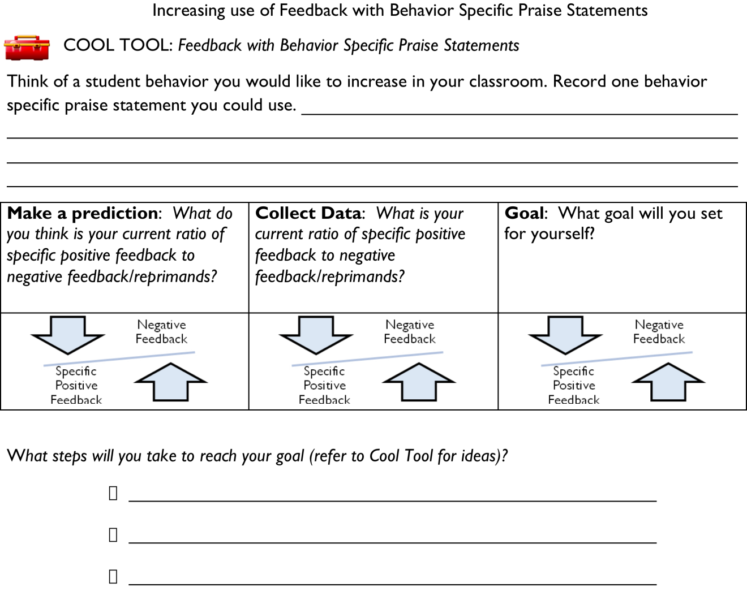

From Susan Barrett, PBIS TA Center

Reinforcement Planning Matrix

|  |  |  |  |  |  |
| --- | --- | --- | --- | --- | --- |
| TYPE | WHAT IT IS | **WHEN WILL IT HAPPEN** | **WHERE CAN/WILL IT HAPPEN** | **WHO WILL BE IMPLEMENTING** | **NOTES** |
| High Frequency “GOTCHAS” |  |  |  |  |  |
| Unpredictable/Intermittent “BOOSTERS” |  |  |  |  |  |
| Attention Grabbing “Celebrations” |  |  |  |  |  |

Based on the work of Steve Romano

Link to Sample Acknowledgment Matrix: <http://hankbohanon.net/userfiles/High_School_PBS/Presentations/Acknowledgement/Sample%20school-wide%20reinforcement%20plan%20PD%20OBJ4%20.doc>

**Professional Development on Redirection**

* Think off a student who is off task
  + What might they be doing that is okay?
  + If a student was in a white shirt but did not have out an ID, what could you say first before asking about the ID?
* When stopping a student in the hall, what happens when you don’t use the techniques below?
  + **Use privacy, eye contact, and proximity** when correcting
  + **Start with something positive** – what are they doing right? Or what is the student next to him doing that is right? Praise that behavior specifically.
  + **Assume the student did not know the expectation** (assume innocence until proven guilty)
  + **Use humor** – this is not sarcasm (e.g., you know, some times my arms just fly around too, are you OK now? – Is this really being safe in the hall?)
  + **Stay out of content** when you ask for something or give a direction. When the students says “why” or “who are you” then simply wait a moment and repeat the direction. You must be willing to wait it out, if not, do not use this!
  + **End with a teachable moment**, “Was that an example of being safe?” “What did you need to do instead?”
* When attempting to redirect groups, have you tried the following?
  + **Acknowledge those who are on task**. When the rest come back, thank them. The same can be done for individual students: look for anything they are doing right, and point that out. When they stop problem behavior, thank them for their self-control without having to be told (Hint: Start with something positive).
  + **Stop, wait** for instructional control, **remind and re-teach** expectations.

**Year at a Glance for PBS (**See <http://hankbohanon.net> for Word Doc**)**

|  |  |
| --- | --- |
| **Summer Vacation** | Training and planning with PBS Team  (Typically three meetings)  Develop guidebook for teachers |
| **August** | Develop action plan for first few months of school (Add to this at each meeting throughout the year)  (Be ready for orientations, guidebook, tickets, store, raffles, data, meetings) |
| **September** | Kickoff for school year: Teach expectations, explain the acknowledgement system to all students and staff.  Pass out guidebook and explain (include policy)  Distribute tickets to all staff members.  Begin to look at target level supports: identify groups  Team meets bi-monthly – review data |
| **October** | School store up and running, consistent raffle drawings.  Prepare for secondary supports, identify needs and data.  Feedback from staff about project  Recruit and orient new team members  Review Team Implementation Checklist  Share data with the staff  Team meets bi-monthly – review data |
| **November** | Begin planning first school-wide celebration  Review data, identify secondary needs  Parent climate survey  Team meets bi-monthly – review data |
| **December** | Possible target month: school-wide celebration, encourage acknowledgment system  Secondary supports – on-going  Review Team Implementation Checklist  Share data with the staff  Team meets bi-monthly – review data |
| **January** | Refresh everyone on school-wide system.  Administer SET  Team meets bi-monthly – review data |
| **February** | Feedback from staff about project and present data |
| **March** | Possible target month: school-wide celebration(?), encourage acknowledgment system  Review Team Implementation Checklist  Share data with the staff  Administer EBS  Team meets bi-monthly – review data |
| **April** | Possible target month: school-wide celebration(?), encourage acknowledgment system  Planning retreat for next steps (all day)  Team meets bi-monthly – review data |
| **May** | Administer Climate survey  School-wide celebration (?)  Team meets bi-monthly – review data |
| **June** | Report summary data to staff and feedback  Review Team Implementation Checklist  Set dates for summer planning/training  Final planning meeting  Team meets bi-monthly – review data |

**SWE Rotational Sessions- Staff Development**

**45 Minutes Each**

1. **Rationale: Who will do overview -** 
   1. Why SWE -
      1. Read through the rationale, make it a point to emphasize the EVERYONE when feeling comfortable, valued and welcome
      2. Review the CIWP goal
      3. SWE is not a closed door committee, it is an always accepting, open team

iv.Get back instructional time, fewer power struggles, adds to more comfortable

and productive classroom environment

v. Data: SET (what you are doing), TIC (team’s perception), SAS (teacher

perception) Highlights from office discipline referrals, Goal 50% reductions in the number of classrooms and teachers with 10 or more referrals, general

reduction in classroom ODRs: Slides: Total ODRs, Triangle, By Class, By Month, By Locations, By Who is involved, By Major and by Minor, By Time

of Day, By Teacher response, By Admin, and Suspensions.

1. **Communication -**

a. Walk through the teacher handbook

b. Overview of committees and their major tasks for the year (year at a glance) based on

our priorities from the Effective Behavior Support Survey (EBS)

1. **Data -** 
   1. Show one page from the EBS from the school wide - (pull graph)
   2. Working together to create one clear set of policies
      1. What did we do on the area of communication from the action plan in the following areas. We want you to help with as much as possible:
         1. Hallway behaviors – transition plans TBA
         2. Overview of rotational meeting for students (short overview)
         3. Consequences for major behaviors or repeat problems (in school problem solving is coming): a. check in and check out as needed, office vs class, procedural flow chart, ODR form (how and when to use - see example and why),
         4. redirection strategies (one pager -in handbook) <http://69.195.124.205/~hankboha/wp-content/uploads/2014/04/Handout-on-Redirection7-13-07-Shorter.doc>
         5. Good example of how to stay out of a power struggle video - see about 6 minutes in - maybe use maybe not <http://vimeo.com/groups/pbisvideos/videos/14818677>
   3. Create an **open** line of communication between all staff (survey is coming - welcome to share with team at any point)
2. **Teaching -** 
   1. Role play teaching example and give example - show clip of teacher teaching expectation (short) .
   2. Great example of teaching expectations - maybe use - maybe not - about 2 Minutes into video <http://vimeo.com/groups/pbisvideos/videos/14818677>
   3. Discuss lesson plans for first two weeks
   4. Boosters and on-going teaching – focus on (PUT THE MONTHS IN HERE FOR RE-Teaching AND BOOSTERS BASED ON MONTHLY GRAPH)
3. **Incentives and Acknowledgements -** 
   1. The intent of this team is to encourage and recognize desired positive behaviors
   2. How to acknowledge (see one pager - in handbook) <http://69.195.124.205/~hankboha/wp-content/uploads/2014/04/Acknowledging-One-Pager.doc>
   3. Staff will be encouraged to establish their own “best” methods of recognizing and acknowledging their students that best fit their own classroom management and organizational styles and needs.
   4. High frequency **School Store System**- stickers and school store - how this works **(See TMMS Acknowledgement Grid)**
   5. **Small Group Awards - Checking for appropriate language, Honor roll, Disrespect Checks, and Acknowledging Teacher (See TMMS Acknowledgement Grid)**
   6. **School Wide Awards:** If the students have over 95% attendance in December they will be rewarded with a school dance on December 21st., 2. If we see a 10% drop in Office Discipline Referrals from February to March we will have a Dance on March 28th. If we see a 10% drop in ODRs from May to June we will have a dance June 14th.**(See TMMS Acknowledgement Grid)**
   7. We are hopeful that we as a school will become more mindful of all of the little (and big) things that are done on a daily basis to help maintain a positive work environment.

**Examples of PLC Schedules for Intervention**

**Adlai Stevenson High School**

• Eight 50-minute periods

• Students take six classes (50 minutes)

• Freshmen and sophomores have one study hall (50 minutes)

• Juniors and seniors passing all classes have one free period

• Freshmen have 25-minute advisory/25-minute lunch

• Sophomores, juniors, and seniors passing all classes have 50-minute lunch

**Bernice MacNaughton High School**

• Supplemental math and English classes based on proficiency assessment

• Math and science lunch labs

• RED (Remediation/Enrichment Days) after common assessments

• Directed learning for 30 minutes at end of day for study, homework completion, tutoring

• Hired full-time guided study teacher

• Seniors can carry lighter load if agree to tutor twice a week

**Cinco Ranch High School**

• Seven periods

• Freshmen must enroll in one study hall to provide time for intervention

• Intensive study skills

• Target math study hall

• Before- and after-school tutoring

* Each teacher tutors twice a week as part of duty

• Choice of detention or tutoring if fail to show

• NHS students tutor during study hall

• Progress reports or report cards every three weeks

• Online credit recovery

**Jane Addams Junior High School**

• Nine-period day, 40 minutes each, with one period reserved for lunch

• Students missing assignments are notified on Friday to go to guided study instead of lunch

• Next they are assigned to an after-school tutorial program three days per week

• Next they are removed from an elective and assigned to an intervention class for support.

• Reading Extension class for lowest readers

• 60-minute math period for remedial math students

**Lakeridge Junior High School**

• Moved from seven-period day to modified A/B block with FLEX time

• Students enroll in four 80-minute periods

• 30 minutes carved out Tuesday–Friday for FLEX time. Failing students report to mandatory

tutoring; all others provided enrichment options or free time.

• Those with continuing academic difficulty can be assigned to a double period of language

arts or math

**Monticello High School**

• Seven-period block

• Tuesdays/Thursdays—Classes begin at 9:00, periods 1, 3, 7 meet for 90 minutes, 55

minutes for lunch

• Wednesdays/Fridays—Classes begin at 9:00, periods 2, 4, 6 meet for 90 minutes, 55

minutes for lunch

• Tuesday–Friday—Period 5 meets for 55 minutes

• Mondays—Required tutorial period from 8:50 to 9:30 for any student not passing classes or

requested by teacher. Classes begin at 9:30, periods 1, 2, 3, 4, 6, 7 meet for 50 minutes, 35

minutes for lunch

• Transition and Orientation Program—Freshmen and transfer students meet in an advisory

program 25 minutes each day for first nine weeks to assist with transition into high school

• CARE Program—Tuesdays through Fridays—Students not passing classes report to tutorial

for first 25 minutes of their lunch period, 30 minutes for lunch

**Washington Academic Middle School**

• Purgatory rather than lunch

• Course deployment after each common assessment (students redistributed to teachers of

same course for intervention or enrichment). Coach, resource specialists, and aides assist.

Students reassessed. Optional for proficient students

• Required intersession for students who fail trimester

• Elective period replaced with academic seminar

• Opportunity class (small, focused class for most-resistant students)

**Whittier High School**

• Mondays—Six-period day, 48 minutes each period

• Tuesday–Friday—Modified block of three classes for 100 minutes for first five weeks

Beginning sixth week, students passing all classes with C are released after 80 minutes for

break, longer lunch, or early dismissal. Students not passing classes remain for intensive

tutoring and small-group work.

How can we enhance the components of an effective school environment?

How do we connect components with effective classroom management?

***List at least 2 Action Steps***

|  |  |  |
| --- | --- | --- |
| **WHAT NEEDS TO BE COMPLETED?** | **WHO** | **WHEN** |
| A. |  |  |
| B. |  |  |
| C. |  |  |
| D. |  |  |