Conference on School Culture, Climate, & Positive Behavior Support
2016

MTSS by Design: Transforming Separate Approaches into a Cohesive Plan
Workbook

August 12, 2016

Hank Bohanon
hbohano@luc.edu
http://www.hankbohanon.net
https://twitter.com/hbohano
https://www.facebook.com/hank.bohanon

Please feel free to use these materials. Please let me know if they are helpful to you and how you use them to support your efforts.

I. Establishing an organizational plan for MTSS

Enduring Understanding: Be able to connect MTSS, school improvement, and healthy school climate for all.

Essential question: How do you organize systems around a clear purpose for improvement to enhance your environment (e.g., human, financial, structural)?

MTSS Connections

Effective Collaboration - system with a clear focus and shared vision (Vermont Agency of Education, Accessed July 27, 2016)

The Significance of an Effective Collaborative School Culture
share a clear mission and vision;
value the interchange of ideas with colleagues;
hold high expectations of everyone, including themselves

(Vermont Reads Institute and Vermont Statewide Steering Committee on RTI, 2014)

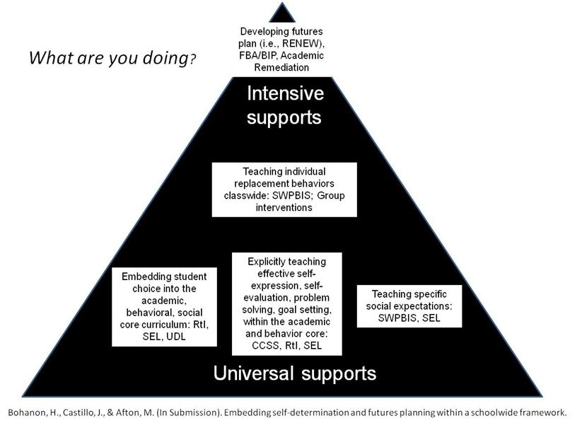

Note. 9th and 10th grade students are expected to express themselves effectively and develop rules for collegial discussions and decision making when working with peers (CCSS.ELA-Literacy.SL.9-10.1 and CCSS.ELA-Literacy.SL.9-10.1b). Learning how to develop and evaluate a plan by gathering information (problem solving) is directly related to standards involving writing (CCSS.ELA-Literacy.WHST.9-10.5 and CCSS.ELA-Literacy.WHST.9-10.8). Skills related to self-advocacy (e.g., making your point effectively) are related to anchor standards for college readiness (CCSS.ELA-Literacy.CCRA.SL.1and CCSS.ELA-Literacy.CCRA.SL.4.). Addressing the key standards may be one effective way to encourage participation in self-determination supports.

Celebrations and Next Steps for MTSS

Process: This could be completed by any member of a school/division leadership team.
Topic: Organizing academic and behavior tiered support at the district/school/division level(s) (e.g., organizing systems, practices, and people; resources; plan development; connection – agreement on “what do we want students to know and be able to do?”; connections with school improvement, working organizational structures of school)

Describe celebrations if any: | Describe future directions if any (what would make your work easier):
Topic: Structure used for communication loops (e.g., how to select programs, developing buy-in, getting input on a plan, communicating a plan, feedback loops with stakeholders)

Describe celebrations if any: | Describe future directions if any (what would make your work easier):
Topic: Effective team meeting process (e.g., scheduling meetings, staying on agenda, using data, expectations for team membership, role descriptions, action planning, connecting with mission and vision of team and school, data decision rules, PLC connection – “what are we going to do if student do not respond?”)

Describe celebrations if any: | Describe future directions if any (what would make your work easier):
Topic: Organizing multiple data sources (data dashboard) (e.g., generating reports that are useful for teams, combining data sets, identifying key data sources for early warning, identifying patterns of needs, connecting interventions with patterns of needs, PLC connection - “how will we know if students are not responding”)

Describe celebrations if any: | Describe future directions if any (what would make your work easier):

Defining your purpose
Tier 1 Mission and Vision
Team structure and purpose (what is and is not the mission of your team, related to your school’s mission)?
What is the mission of your universal tier I team? (Example The mission of the universal team is to increase the likelihood of positive behavior, social, emotional, and academic achievement of our students). If needed, think about what you will not do..

Your statement?

What is the vision (e.g., what are your outcomes – related to what do you want all students to know and be able to do?)
Examples:
- To work with students and their families to identify core climate supports to prevent health/behavioral/attendance/social/academic concerns.
- To identify reliable predictors of students performance.
- To determine likely source of problem and recommend changes to core interventions based on needs.
- To assist and support teachers, students, and parents in achieving efficient and effective universal interventions.
Your statement?

Alternative: Write and/or draw the purpose of MTSS on a napkin, they will present to colleague as though they were at a party and someone asked about MTSS.

Determine your next step.
Based on your team time discussion, list at least 1 action statement.

WHAT NEEDS TO BE COMPLETED? | WHO | WHEN
A.
B.

C.

D.

II. Enduring Understanding: Be able to identify ways to work smarter and not harder

Essential question: What are effective methods to consolidate actions and activities and ensure all tasks are aligned with our mission.

MTSS Connections

Careful assessment and allocation of resources – people, time, and materials (Vermont Reads Institute and Vermont Statewide Steering Committee on RTI, 2014)

Activity: Use the blank triangle on the following page to complete Activity:

Step 1: Identify all programs/initiatives/common practices by tier
Tier I- How do you support all children? Core Curriculum- “everyone gets”
Tier II, III. How do you support students who need more support? How do you build on the foundation so that all Tier II, III activities are a natural extension of core curriculum?

Other considerations:
Can you identify outcome for each practice? How do you measure effectiveness?(Staff performance) How do monitor progress? (student impact) How do you support teachers? (staff support)How are they linked to School Improvement? (integrated approach)

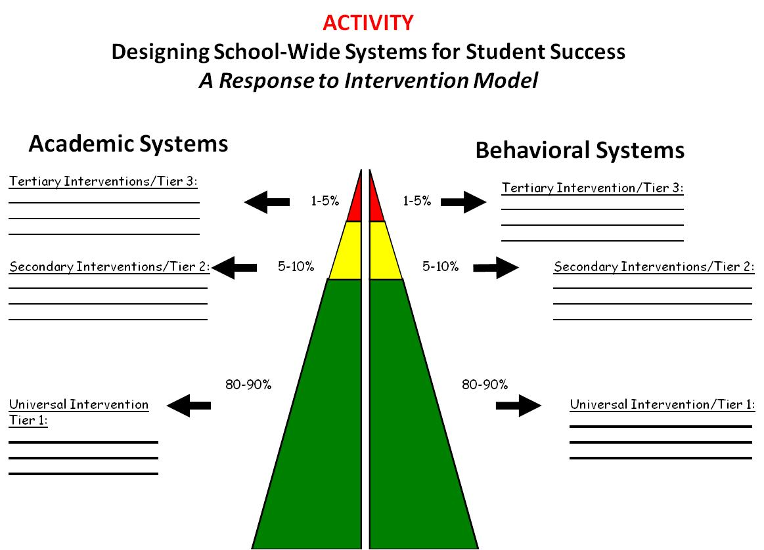

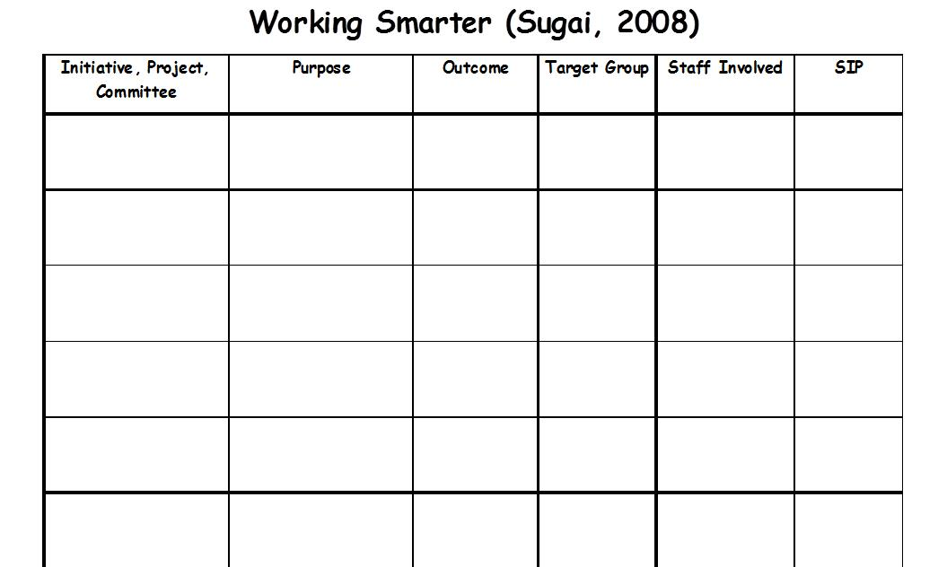
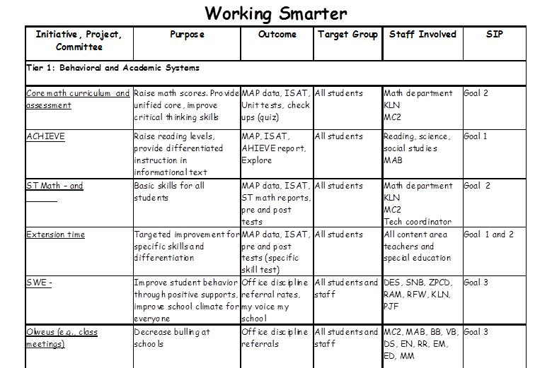

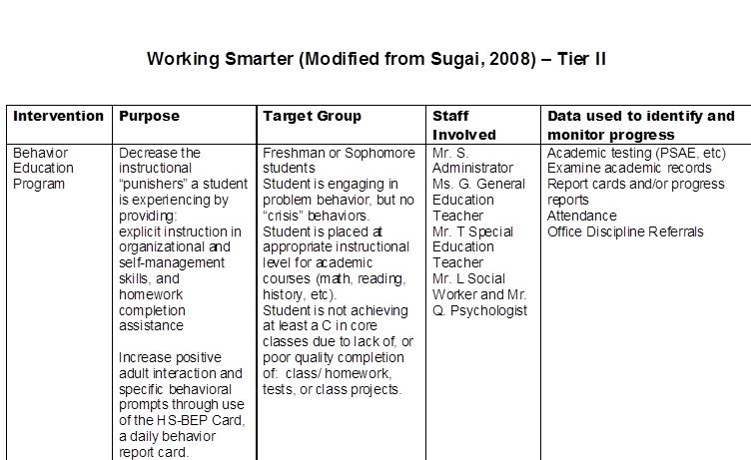

Link to Behavior Education Program: http://miblsi.cenmi.org/LinkClick.aspx?fileticket=XqRfz3O9AFo%3d&tabid=1855

Reflection: Based on your school improvement needs, what is the one initiative you could focus on that would make everything else easier or not as necessary?

Consider what communication structures for sharing information and data you have in place now and discuss what opportunities you haven’t explored yet. Record your team’s discussions.

Determine your next step.
Based on your team time discussion, list at least 1 action statement.

WHAT NEEDS TO BE COMPLETED? | WHO | WHEN
A.
B.

C.

D.

III. Healthy Team Functioning

Enduring Understanding: Be able to identify and implement components of healthy teams

Essential question: How do you organize personnel in ways to support to enhance the support in your environment (e.g., teachers, school psychologists)?

VT School Climate, 13 Dimensions of School Climate:
Domain 4 Interpersonal Relationships: Leadership and Professional Relationships

MTSS Connections

Effective Collaboration
- System with a clear focus and shared vision; and
- Roles and Responsibilities - develop a common framework within which to work and communicate, including a shared
- Consideration of roles and responsibilities;

The Significance of an Effective Collaborative School Culture
- share a clear mission and vision,
- value the interchange of ideas with colleagues; and
- hold high expectations of everyone, including themselves
- employ clearly-defined norms that indicate desired behaviors/types of communication that create a safe environment for their shared work;

Characteristics of effective teams
- identify roles and responsibilities related to specific processes and decisions aimed at positive change; (Vermont Reads Institute and Vermont Statewide Steering Committee on RTI, 2014)

Sample Model
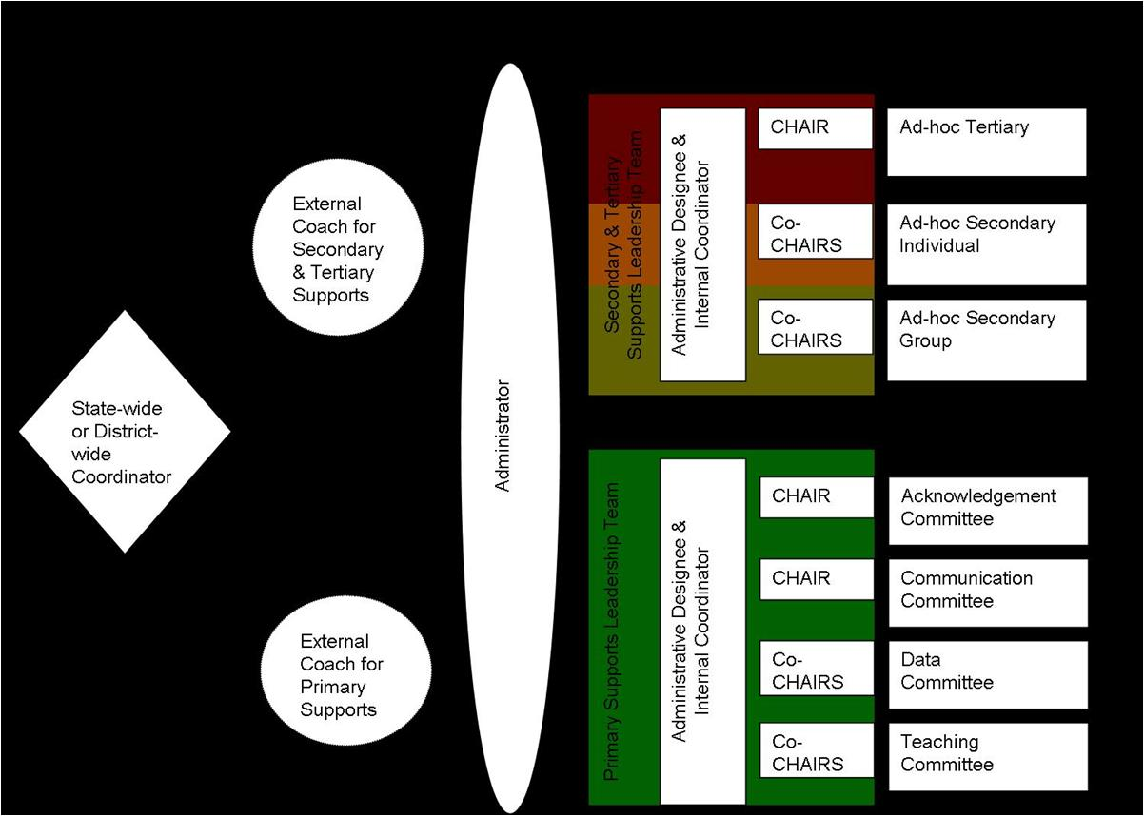

Universal Support Positions
Position | Description | Approximate Time Allocated for Position | Possible Individual to Fill this Position

District Administration
District Level Administrator (Director of Secondary Schools) | Makes administrative decisions that will support MTSS efforts at the building level (e.g. resources, supporting initiative expectations) and provides input on recommended building level approach | Available for quarterly check in meetings and ongoing communication when necessary
Building Level Administrator Representative | Provide building level perspective of feasibility of MTSS implementation | Available for quarterly check in meetings and ongoing communication when necessary
Curriculum Director | Support adoption of scientifically research based practices in core content academic areas | Available for quarterly check in meetings and ongoing communication when necessary
Director of Support Services | Provide support for implementation of scientifically research based practices for students at-risk or identified students with needs (e.g. receiving special education services) | Available for quarterly check in meetings and ongoing communication when necessary
Director of Discipline/School Safety | Provide support for implementation of research based practices for behavioral supports at the building level within the district | Available for quarterly check in meetings and ongoing communication when necessary

District Based Staff
Districtwide Coordinator (3 Tier Prevention) | Oversees support and training of MTSS initiatives within a 3 Tier Prevention Model (e.g. RtI, PBIS, SEL) in district schools | Primary Responsibility
External Coach (primary supports) | Provide support and training with MTSS implementation, data analysis, and sustainability at the schoolwide level (e.g. support team meetings, organize data) | 10-20 hours a week

Building Based Staff
School Liaison | Administrator who oversees functioning and makes administrative decision for all tiers of MTSS within the building (e.g. attends meetings, allocates resources) | 10 hours a month
Internal Coordinator (Primary Support Leader Team) | Internal staff who can lead staff, with support from the External Coach, in implementing MTSS schoolwide academics and behavior practices, run meetings and oversee sub-committees | 10 hours a month
Acknowledgement CHAIR | Lead the acknowledgement of student and staff behavior for schoolwide efforts, sub-committee in planning for celebrations and reinforcement systems within the school, meet with internal coordinator 2 times a month | 8 hours a month
Acknowledgement Sub-committee | Facilitate schoolwide acknowledgment activities, including design and implementation. | 4 hours a month
Data CHAIR (co-chairs) | Lead the data sub-committee in reviewing schoolwide academic and behavior data on a continuous basis to determine school needs and ongoing evaluation of implementation (e.g. ODRs, CBM). Prepares reports for schoolwide academic and behavior meetings, meets with internal coordinator 2 times a month | 8 hours a month per co-chair
Data Sub-committee | Facilitate schoolwide data activities, including collection and dissemination of relevant school data. | 4 hours a month
Teaching CHAIR (co-chairs) | Lead the teaching sub-committee in development of behavioral based lesson plans (e.g. lessons that teach expectations) around school needs (determined by data review) and support implementation of scientifically research based academic practices and curriculum (e.g. core curriculum review, Universal Design), meets with internal coordinator 2 times a month | 8 hours a month per co-chair
Teaching Sub-Committee | Facilitate schoolwide teaching activities, including the development of behavioral based lessons plans. | 4 hours a month
Communication CHAIR | Lead the communication sub-committee in development of plans and organization of initiative information to communicate to staff and students, meets with internal coordinator 2 times a month | 8 hours a month
Communication Sub-Committee | Facilitate schoolwide communication activities, including the development of plans and organization of relevant information to staff and students. | 4 hours a month

V. Organizing multiple data sources

Enduring Understanding: How can you use data to plan for interventions – at the beginning of the year and on-going?

Essential Questions: How can teams convert data to a plan of action based on fidelity and outcomes?

Connections with VT MTSS

Comprehensive and Balanced Assessment System

Screening
Identify or flag students who are struggling or may be at-risk of school failure and who will require closer monitoring; and
Monitoring the effectiveness of core academic and behavioral curricula; (Vermont Reads Institute and Vermont Statewide Steering Committee on RTI, 2014)

Using Schoolwide Data (Dowdy, Ritchey, and Kamphaus, 2010):

Reflective question: Based on what works for using schoolwide data, where are you? What are your action steps?

1. Establishing a team to guide planning and implementation
2. Identifying the purpose and specific goals for screening within a school settings (SEL - PLC 1)
3. Examining the utility of screening tools in light of the purposes of screening (PLC 2)
4. Selecting screening tools that are linked to goals (PLC 2)
5. Identifying available resources to provide interventions in the school settings based on screening outcomes (PLC 3)
6. Developing a specific timeline and process for data collection (e.g., action plan) (PLC 3)
7. Sharing the results with stakeholders (e.g., teachers, schools, and individual students), studying and reporting data to district level personnel. (PLC 3)

Sample Dashboard for Schoolwide Review

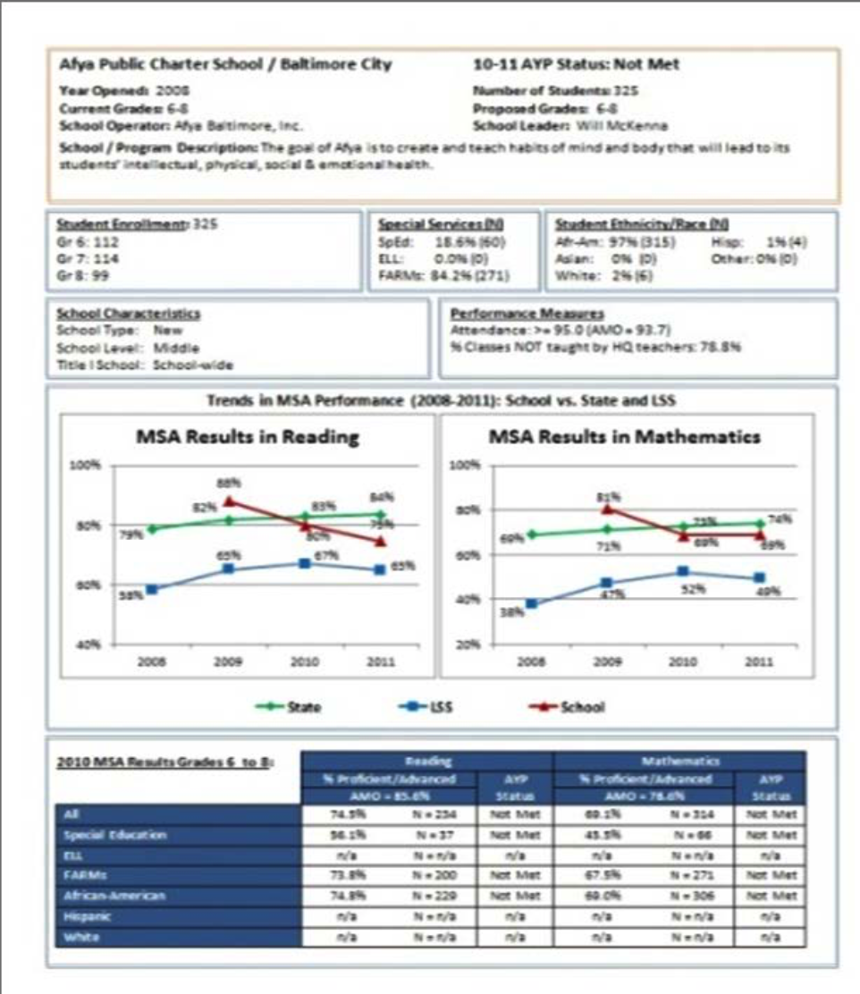

(From https://www.relmidatlantic.org/content/creating-and-using-automated-data-dashboards-webinar-0)

Creating and Using Automated Dashboards Presented by Rosemarie O’Conner, Ph.D.

Step 1: Make a model report in Word
• Create a model of what you want your “final” copy to look like and populate your charts and tables with fictional data

Step 2: Add bookmarks to your model report
a) Print your model report and circle or highlight every single detail that needs to change from one report to another – words, numbers, tables, charts, etc.
b) Add bookmarks in Word a. Make your bookmarks visible to keep yourself organized: Word Options → Advanced → Show document contents → Show bookmarks

c) Make a list of every single one of the bookmarks you just created
d) Save this Word document with the bookmarks as a .dotx file (This is called a Word “template”)

Step 3: Organize the data in Excel
- Make a “setup” sheet with 3 columns:
o Column of dashboard data – the column where the datum is going to come from
o Bookmark name
o Short description of the bookmark to keep yourself organized

b) Make a “data” sheet o Transpose the data from the “Setup” into the first 3 rows of the “Data” sheet
o Fill in your data! ▪ Use the =text() function to convert all numbers to text

- Make your “charts” sheet
o Generate all the charts beforehand (and edit them individually before finalizing the report)
o Each chart has a name, and you have to record that name

Step 4: Run the code
a) Code info sheet o Add the name of the template you created
o Add the name of the folder where you want the completed reports to be stored
o Add the row number where the actual data begin

b) Run the macro

(From https://www.relmidatlantic.org/forums/creating-and-using-automated-data-dashboards-0

VI. Effective classroom instructional models based on universal supports

Enduring Understanding: Be able to identify the components of engaging environments that prevent and address problem behavior for students

Essential Questions: What are the components of effective school environments? How do these components connect with an effective instructional model (practices)?

Connections with MTSS

Develop coherent and consistent curriculum and behavior practices that guide instruction and intervention to improve outcomes for all students

Establish and Monitor Systemic Structures
- Articulate core curricula.
- Align curriculum, standards, instruction and assessment.
- Assessments need predictive validity
- Data are most useful at transition points: middle to high, elem to middle; (Vermont Reads Institute and Vermont Statewide Steering Committee on RTI, 2014)

MTSS and School Climate
Domain 1 Safety: Behavioral Expectations, Sense of Social and Emotional Security; Domain 2 Physical Environment: School Connectedness & Community Engagement; Domain 3 Teaching and Learning: Social Skills Development, Student Engagement and Self Direction;
Domain 4 Interpersonal Relationships: Social Supports for Students; (Vermont Agency of Education, Accessed July 27, 2016)
Activity: Based on what we have discussed, what is one thing you can do that will make every other part of your MTSS more aligned in terms of your vision, personnel, and practices?
- Connect MTSS, school improvement, and healthy school climate
- Prioritize efforts
- Develop teams
- Organize multiple data sources
- Select effective instructional models

List at least 1 Action Step

WHAT NEEDS TO BE COMPLETED? | WHO | WHEN
A.

B.

C.

D.

References

Bohanon, H., Castillo, J., & Afton, M. (2015). Embedding self-determination and futures planning within a schoolwide framework. Intervention in School and Clinic. 50 (4), 203-209. http://ecommons.luc.edu/education_facpubs/16/

Dowdy, E., Ritchey, K., & Kamphaus, R. W. (2010). School-based screening: A population-based approach to inform and monitor children's mental health needs. [References]. School Mental Health, 2(4), 166-176. doi:10.1007/s12310-010-9036-3

Vermont Agency of Education (Accessed July 28, 2016). The 13 dimensions of school climate. Vermont Agency of Education, Retrieved from: http://education.vermont.gov/documents/edu-school-climate-13%20Dimensions.pdf

Vermont Reads Institute and Vermont Statewide Steering Committee on RTII (2014).
Vermont multi-tiered system of supports response to intervention and instruction (MTSS-RtI) self-assessment. Vermont Reads Institute, University of Vermont, Burlington, VT. Retrieved from http://www.vriuvm.org/MTSS-RtII/wp-content/uploads/2014/06/MTSS-RtII-SelfAssessment-062014.pdf

