**Kansas MTSS Symposium**

**2017**

**Preparing for Acknowledgement Systems for PBIS in Secondary Schools**

**September 13, 2017**

Hank Bohanon

hbohano@luc.edu

<http://www.hankbohanon.net> (sign up for updates)

<https://twitter.com/hbohano>

<https://www.facebook.com/hank.bohanon>

Please feel free to use these materials. Please let me know if they are helpful to you and how you use them to support your efforts.

**I. Establishing an organizational plan for MTSS**

**Enduring Understanding:** Be able to identify the components of preparing staff and establishing buy-in related to school climate.

**Essential Questions:** How do you prepare systems to enhance the support in your environment (e.g., human, financial, structural)?

**Connections to TASN Innovation Configuration Matrix (ICM):**

LE 10: The leadership team, all staff, families, and community collaborators have developed knowledge of and come to consensus regarding the implementation of MTSS.

LE 11: Professional development for staff members and family involvement opportunities are aligned with the principles and practices of MTSS and include ongoing support and coaching.

Sample Interview Questions for developing buy-in (newer teams)

|  |  |
| --- | --- |
| What is going well in your school around behavior/discipline? |  |
| What are some of the barriers to teaching around discipline? |  |
| What would you like to change about your job AROUND DISCIPLINE? |  |
| Can you say anything about who, when, where, what, and why about problem behaviors and/or desirable behaviors occur in your building? |  |
| What have you liked/disliked about staff development in the past? |  |

Adapted from the work of Jim Knight by Hank Bohanon (hbohano@luc.edu) and the Louisiana PBS Project

Sample Interview Questions for developing buy-in (established teams)

Please answer the questions below about MTSS/PBIS.

1. What do you like MOST about the implementation of MTSS/PBIS?

2. What do you like LEAST about the implementation of MTSS/PBIS?

3. How do you feel the implementation of MTSS/PBIS could be IMPROVED?

4. How often do you hand out wristbands?

Circle ONE: Never Monthly Weekly

5. What suggestions do you have for reinforcers (rewards) for students? (Think of things

that may or may not cost money).

6. What suggestions do you have for reinforcers for teachers whose names are called

when a wristband is chosen?

Amy Kroll

9-12 Special Education Teacher/Transition Specialist

1829 Central Ave.

Auburn, NE 68305

(402)-274-4328

akroll@esu4.org

**Sample Results**

1. What do you like MOST about the implementation of PBIS?

Have seen an improvement in student behavior (5)

Uniformity and consistency (7)

Get to meet kids they don’t know

Lessons (2)

Kids pick up after themselves

Helps w/social skills

Teaches positive expectations

Wristbands (2)

½ hour of work time for teachers

Awareness of students doing positive things

Discussion of difficult topics with the kids

6-12 Building wide

See same kids every day for set amount of time

Positive behavior enforcement is more effective than negative

Kid’s reaction when name is drawn for wristband

Videos

Clear consequences, good rewards

Working w/students that need extra help

The review of major issues-parking, technology, hallway decorum

No Comment (2)

2. What do you like LEAST about the implementation of PBIS?

Repetition of simple lessons (6)

Lesson effectiveness (2)

Lessons are too elementary (2)

No feedback from teachers

Read-only topics

Wish it could extend to the classroom

Not being visible in other areas than the hall

Teaching partner’s lack of effort and attitude toward students

One partner does all the lessons, work, talking

Filing out the forms, forgetting about doing them (3)

Not having all the materials for the lessons beforehand

Most students have nothing to do (2)

Not everyone rewarding the same things

Students aren’t taking lessons seriously (2)

Rewarding behavior that should be expected from students

Clipboards

The lessons are getting shorter

Students are still treating the positives as jokes

Kids thinking they need a wristband for everything

I like everything about it!

Teachers need to be more consistent

No Comment (1)

3. How do you feel the implementation of PBIS could be IMPROVED?

Use multimedia for lesson presentation

Expand to classroom (4)

Increase rewards

More group activities

More speakers

Change lessons, too repetitive, gear toward high school (2)

Wristband stipulations need to be more clear-teachers are handing out

wristbands for behaviors not on the matrix

Shorter

How we recognize the wristband winners

Everyone following the same rules (2)

More activities to reinforce lessons

ARC Time is too long

Students have lost focus of purpose 2nd semester

More relevant movies on Youtube

Have monthly meetings w/teachers

Keep educating staff about steps to take various situations

Apply consequences withinin one day

No comment (13)

4. How often do you hand out wristbands?

Circle ONE: Never (7)

Weekly (4)

Monthly (18)

Other (3)

Amy Kroll

9-12 Special Education Teacher/Transition Specialist

1829 Central Ave.

Auburn, NE 68305

(402)-274-4328

akroll@esu4.org

**More Self-Assessment Tools**

Behavior See: – <http://www.pbisapps.org> see Self Assessment Survey;

Academic and behavior Self-Assessment for Buy-In (Niles West High School): <https://docs.google.com/spreadsheet/viewform?usp=sharing&formkey=dHFnSWtjRzdiY1k4M0w0b2kxWHMwNVE6MA#gid=0>

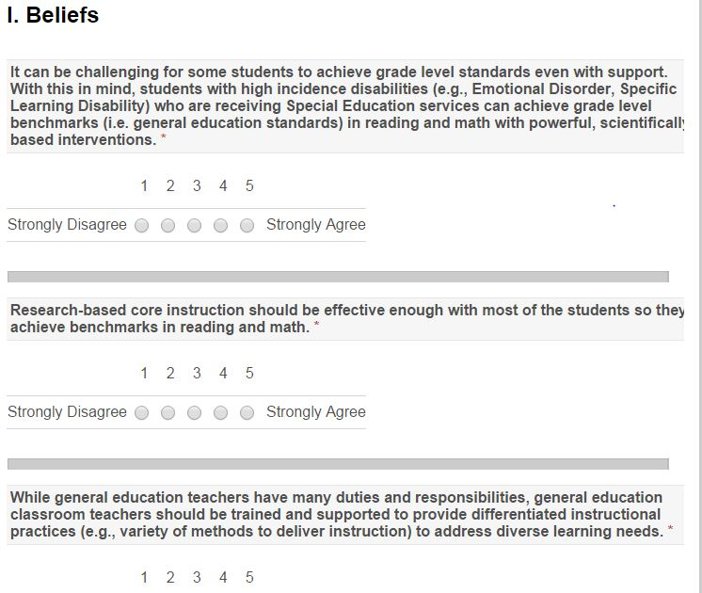

Adapted from http://www.floridarti.usf.edu/resources/program_evaluation/ta_manual_revised2012/index.html - See Tools for Examining Consensus Development

PBIS Action and Commitment Tool (PBIS-ACT) by Kevin Filter

See this link for more information <http://sbs.mnsu.edu/psych/psyd/people/filter/>

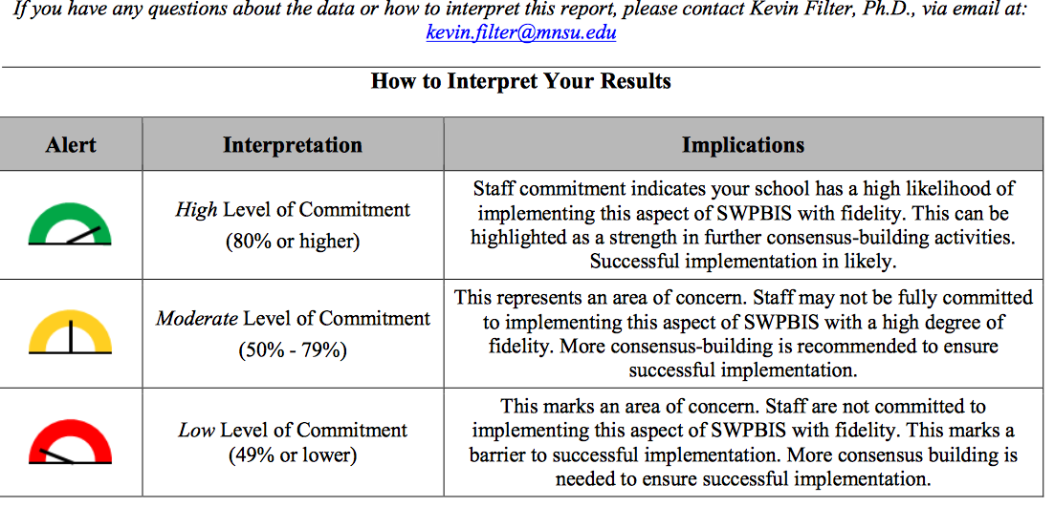Filter, K. J., Sytsma, M. R., & McIntosh, K. (2016). A Brief Measure of Staff Commitment to Implement School-Wide Positive Behavioral Interventions and Supports. *Assessment for Effective Intervention, 42*(1), 18-31.

**What works with EBPS**

See the components of evidenced-based practices

What Works with EBPs; Foreman, Olin, Hoagwood, Crowe, and Saka, 2009)

* the development of support from the administration (e.g., principal);
* obtaining support from teachers (e.g., priority);
* obtaining financial resources to sustain the project (e.g., FTE);
* providing effective training and coaching to increase fidelity;
* the alignment of the interventions with the schools’ goals, philosophy, policies, and programs (e.g., PLC);
* making sure program outcomes are visible to all stakeholders (e.g., share data); and
* developing processes to address the change in staff and administrators (e.g., plan, manual, specified roles).

Reflective question: Can you think of times when these were applied with success? Or perhaps non-examples?

Alternative: Participants will develop a short overview of MTSS on a napkin, they will present to colleague as though they were at a party and someone asked about MTSS.

Determine your next step.

Based on your team time discussion, list at least 2 action statements.

|  |  |  |
| --- | --- | --- |
| **WHAT NEEDS TO BE COMPLETED?** | **WHO** | **WHEN** |
| A. |  |  |
| B. |  |  |
| C. |  |  |
| D. |  |  |

**II. Healthy Team Functioning**

**Enduring Understanding:** Be able to identify and implement components of healthy teams

**Essential question:** How do you organize personnel in ways to support to enhance the support in your environment (e.g., teachers, school psychologists)?

**VT School Climate, 13 Dimensions of School Climate:**

Domain 4 Interpersonal Relationships: Leadership and Professional Relationships

**Connections to TASN Innovation Configuration Matrix (ICM):**

LE 1: Formal leadership teams exist at all levels (e.g., district, building, and site) and include representation from:

• Administration

• Staff

• Learners

• Families

• Community Collaborators

LE 3: The roles and responsibilities of each leadership team member are clearly identified and agreed upon by the team as a whole.

DBDM 1: Clearly identified teams conduct data-based decision making at each level:

• System (District/Building/Site)

• Supplemental Instruction

• Intensive Instruction

DBDM 2: All teams have a clear and consistent understanding of their roles and responsibilities to make decisions about the implementation, sufficiency and effectiveness of the curriculum and instruction, and have a forum to influence changes.

DBDM 5: A clearly identified team meets at regularly scheduled times to analyze system-wide data for academic and behavioral decision making.

* To assist and support teachers, students, and parents in achieving efficient and effective universal interventions.

**Sample Model**

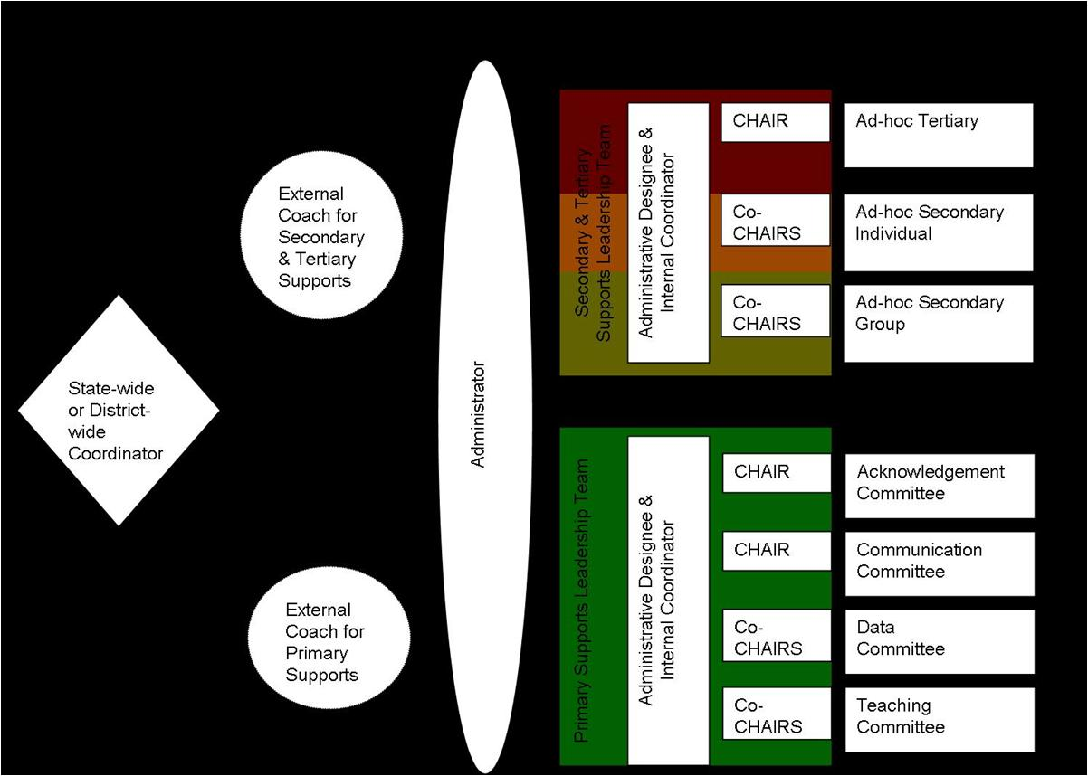

**Universal Support Positions**

|  |  |  |  |
| --- | --- | --- | --- |
| **Position** | **Description** | **Approximate Time Allocated for Position** | **Possible Individual to Fill this Position** |

|  |  |  |  |
| --- | --- | --- | --- |
| **District Administration** | | | |
| District Level Administrator (Director of Secondary Schools) | Makes administrative decisions that will support MTSS efforts at the building level (e.g. resources, supporting initiative expectations) and provides input on recommended building level approach | Available for quarterly check in meetings and ongoing communication when necessary |  |
| Building Level Administrator Representative | Provide building level perspective of feasibility of MTSS implementation | Available for quarterly check in meetings and ongoing communication when necessary |  |
| Curriculum Director | Support adoption of scientifically research based practices in core content academic areas | Available for quarterly check in meetings and ongoing communication when necessary |  |
| Director of Support Services | Provide support for implementation of scientifically research based practices for students at-risk or identified students with needs (e.g. receiving special education services) | Available for quarterly check in meetings and ongoing communication when necessary |  |
| Director of Discipline/School Safety | Provide support for implementation of research based practices for behavioral supports at the building level within the district | Available for quarterly check in meetings and ongoing communication when necessary |  |

|  |  |  |  |
| --- | --- | --- | --- |
| **District Based Staff** | | | |
| Districtwide Coordinator (3 Tier Prevention) | Oversees support and training of MTSS initiatives within a 3 Tier Prevention Model (e.g. RtI, PBIS, SEL) in district schools | Primary Responsibility |  |
| External Coach (primary supports) | Provide support and training with MTSS implementation, data analysis, and sustainability at the schoolwide level (e.g. support team meetings, organize data) | 10-20 hours a week |  |

|  |  |  |  |
| --- | --- | --- | --- |
| **Building Based Staff** | | | |
| School Liaison | Administrator who oversees functioning and makes administrative decision for all tiers of MTSS within the building (e.g. attends meetings, allocates resources) | 10 hours a month |  |
| Internal Coordinator (Primary Support Leader Team) | Internal staff who can lead staff, with support from the External Coach, in implementing MTSS schoolwide academics and behavior practices, run meetings and oversee sub-committees | 10 hours a month |  |
| Acknowledgement CHAIR | Lead the acknowledgement of student and staff behavior for schoolwide efforts, sub-committee in planning for celebrations and reinforcement systems within the school, meet with internal coordinator 2 times a month | 8 hours a month |  |
| Acknowledgement Sub-committee | Facilitate schoolwide acknowledgment activities, including design and implementation. | 4 hours a month |  |
| Data CHAIR (co-chairs) | Lead the data sub-committee in reviewing schoolwide academic and behavior data on a continuous basis to determine school needs and ongoing evaluation of implementation (e.g. ODRs, CBM). Prepares reports for schoolwide academic and behavior meetings, meets with internal coordinator 2 times a month | 8 hours a month per co-chair |  |
| Data Sub-committee | Facilitate schoolwide data activities, including collection and dissemination of relevant school data. | 4 hours a month |  |
| Teaching CHAIR (co-chairs) | Lead the teaching sub-committee in development of behavioral based lesson plans (e.g. lessons that teach expectations) around school needs (determined by data review) and support implementation of scientifically research based academic practices and curriculum (e.g. core curriculum review, Universal Design), meets with internal coordinator 2 times a month | 8 hours a month per co-chair |  |
| Teaching Sub-Committee | Facilitate schoolwide teaching activities, including the development of behavioral based lessons plans. | 4 hours a month |  |
| Communication CHAIR | Lead the communication sub-committee in development of plans and organization of initiative information to communicate to staff and students, meets with internal coordinator 2 times a month | 8 hours a month |  |
| Communication Sub-Committee | Facilitate schoolwide communication activities, including the development of plans and organization of relevant information to staff and students. | 4 hours a month |  |

**CAIRO PLAN**

**(Bolman & Deal, 2002)**

|  |  |  |  |  |  |
| --- | --- | --- | --- | --- | --- |
| **Task** | **Who is Consulted?** | **Who has ultimate Approval?** | **Who should be Informed?** | **Who is Responsible for carrying it out?** | **Who can be Out of the loop?** |
|  |  |  |  |  |  |
|  |  |  |  |  |  |
|  |  |  |  |  |  |
|  |  |  |  |  |  |
|  |  |  |  |  |  |
|  |  |  |  |  |  |

Action Plan Tuesday

Status: C= Complete, I=In progress, N=Not started

|  |  |  |  |
| --- | --- | --- | --- |
| **Task** | **Who** | **When** | Status |
| **Define outcomes of core instruction** | Whomever wants to help | At some point | ? |
| **Fix bad behaviors** | Mrs. B. | By tomorrow | Hurry! |

(contact Hank Bohanon [hbohano@luc.edu](mailto:hbohano@luc.edu))

**Bad Meeting Example**

Team Meeting Friday!!!

We will be discussing the following agenda items:

• Problems

• Ideas

Meeting notes from Friday

3:00 – Two team members were present

3:15 – Two present team members realized that time and place had not been announced

3:20 – Announcement made over loudspeaker

3:40 – All 8 team members present

3:45 – Team had an in-depth discussion about the problems with the raffle system. Comments included the following:

Mr. A. and Mr. B. feel that not enough teachers are using the raffle tickets, and that we should track somehow which ones are not.

Ms. C., Mr. D. and Ms. E. all feel that teachers should do this voluntarily and should not be punished for not using it. (This discussion went on until 4:05, with no resolution, when the next issue was raised).

Ms. F. commented that many times the raffles do not happen at all because there is no system for them. Ms. G. and Ms. H. offered the idea of setting up a schedule. The team debated the pros and cons of a schedule. Mr. A feels that a schedule makes things to rigid and is a problem if someone is out sick. Ms. D. agreed. Ms. G. and Ms. H. felt it would be better than the current situation. At 4:30, Ms. H. and Mr. A. began shouting and pointing fingers at each other, at which point Ms. G. and Mr. B. stood up and called for an end to the discussion since the meetings typically end at 4:15 and more business needed to be covered.

4:30 – Mr. B. brought up the issue of having a meeting facilitator. Ms. C. told a story about one staff member who ruined a team by becoming the leader and behaving like a tyrant. Ms. D. told a story similar to that of Ms. C.

4:45 – The team agreed to disagree for the time being and set another meeting for Monday, time and place TBA.

Adapted from reality Kira Hicks, Contact Hank Bohanon [hbohano@luc.edu](mailto:hbohano@luc.edu) or <http://www.hankbohanon.net>

**Effective Meetings**

**Reflection Activity**

1. Rate the health of their teams on each item

* 1. 5 positive things are going great
  2. 1 not at all and we need to work on this
* __Scheduling and communication
* __Creation and use of an agenda
* __Meeting begins and ends on-time
* __Keeping the meeting on track
* __Action plan/delegating tasks
* __Meeting Participation
* __Dissemination of meeting notes

For full self-assessment on teaming see <http://bit.ly/1dPG4LX>

**VTSS Team Meeting and Problem-Solving Action Planning Form**

|  |  |  |  |  |  |  |
| --- | --- | --- | --- | --- | --- | --- |
| **Today’s Meeting:** | Date: | Time: Click | Location: Click | Facilitator: Click | Minute Taker: Click | Data Analyst: Click |
| **Next Meeting:** | Date: | Time: Click | Location: Click | Facilitator: Click | Minute Taker: Click | Data Analyst: Click |

**Team Members (bold are present today):** Click here to enter text.

|  |  |  |  |  |
| --- | --- | --- | --- | --- |
| Today’s Agenda Items Next Meeting Agenda Items | | |  | Potential Problems Raised |
| 1. Celebrations 2. Click here to enter text. 3. Click here to enter text. |  | 1. Celebrations 2. Click here to enter text. 3. Click here to enter text. |  | 1. Click here to enter text. |

Administrative/General Information and Issues

| Information for Team, or Issue for Team to Address | Discussion/Decision/Task (if applicable) | Who? | By When? |
| --- | --- | --- | --- |
| Aligned Organizational Structure |  |  |  |
| Data Informed Decision-Making |  |  |  |
| Evidence Based Practices |  |  |  |
| Family, School and Community Partnerships |  |  |  |
| Monitoring Student Progress |  |  |  |
| Evaluation of Process |  |  |  |

|  |  |  |  |
| --- | --- | --- | --- |
| **Evaluation of Team Meeting** (Mark your ratings with an “X”) | Our Rating | | |
|  | Yes | So-So | No |
| 1. How well did we use our norms of collaboration in the meeting today? | 🞏 | 🞏 | 🞏 |
| 2. In general, did we do a good job of tracking whether we’re completing the tasks we agreed on at previous meetings? | 🞏 | 🞏 | 🞏 |
| 3. In general, have we done a good job of actually completing the tasks we agreed on at previous meetings? | 🞏 | 🞏 | 🞏 |
| 4. In general, are the completed tasks having the desired effects on student behavior? | 🞏 | 🞏 | 🞏 |
| If some of our ratings are “So-So” or “No,” what can we do to improve things? Click here to enter text. | | | |

**Virginia’s MTSS Action Planning Guide** [**http://www.doe.virginia.gov/instruction/virginia_tiered_system_supports/index.shtml**](http://www.doe.virginia.gov/instruction/virginia_tiered_system_supports/index.shtml)

**Activity:** Review “Early Stages for implementation”

Given your current setting –where are you in the Exploration Phase?

What might be some key experiences you can use to bring along your staff?

Link to article <http://ecommons.luc.edu/education_facpubs/17/>

**Reflection:** How will you encourage your teams to meet effectively?

Determine your next step.

Based on your team time discussion, list at least 1 action statement.

|  |  |  |
| --- | --- | --- |
| **WHAT NEEDS TO BE COMPLETED?** | **WHO** | **WHEN** |
| A. |  |  |
| B. |  |  |
| C. |  |  |
| D. |  |  |

**III. Enduring Understanding**: Be able to identify ways to work smarter and not harder

**Essential question:** What are effective methods to consolidate actions and activities and ensure all tasks are aligned with our mission.

**Connections to TASN Innovation Configuration Matrix (ICM):**

C 1: Staff members have formally evaluated and documented the adequacy of all the academic and behavioral curricular materials used across tiers and ensured alignment to learner needs, state standards and the evidence base.

C 5: Staff members select academic curricula, behavioral instructional materials, and programs/processes for supporting learner behavior that are an appropriate match for the needs of the learners at all tiers, based upon data.

I 3: Staff members select evidence-based instructional practices/strategies that are an appropriate match for the needs of the learner, academically and behaviorally.

**Activity:** Use the blank triangle on the following page to complete Activity:

Step 1: Identify all programs/initiatives/common practices by tier

Tier I- How do you support all children? Core Curriculum- “everyone gets”

Tier II, III. How do you support students who need more support? How do you build on the foundation so that all Tier II, III activities are a natural extension of core curriculum?

Other considerations:

Can you identify outcome for each practice? How do you measure effectiveness?(Staff performance) How do monitor progress? (student impact) How do you support teachers? (staff support)How are they linked to School Improvement? (integrated approach)

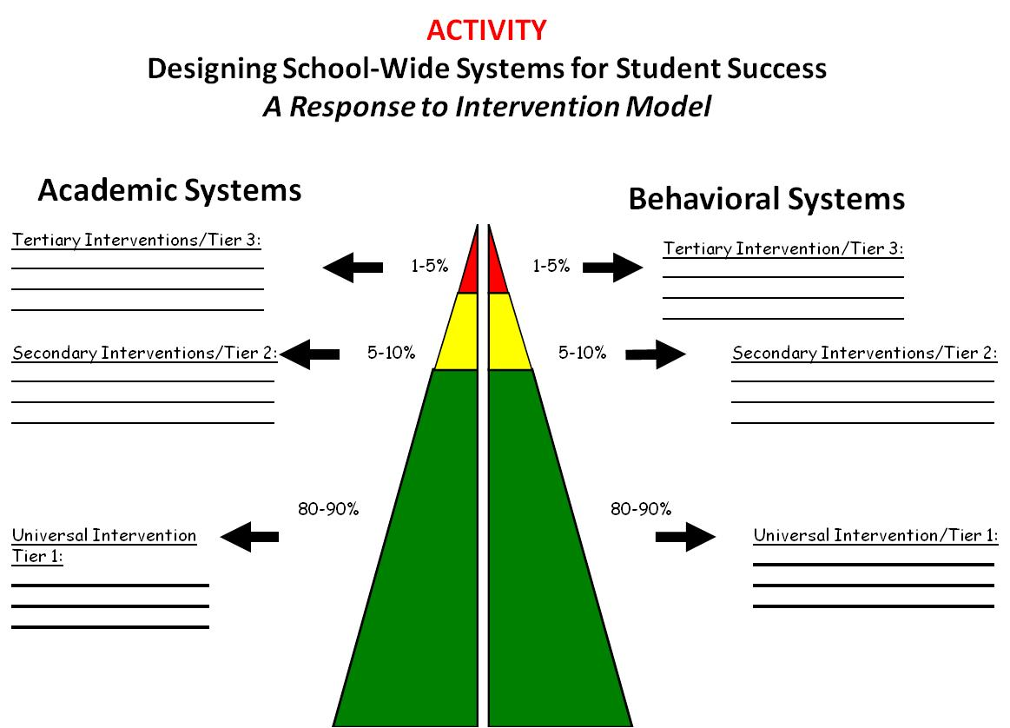

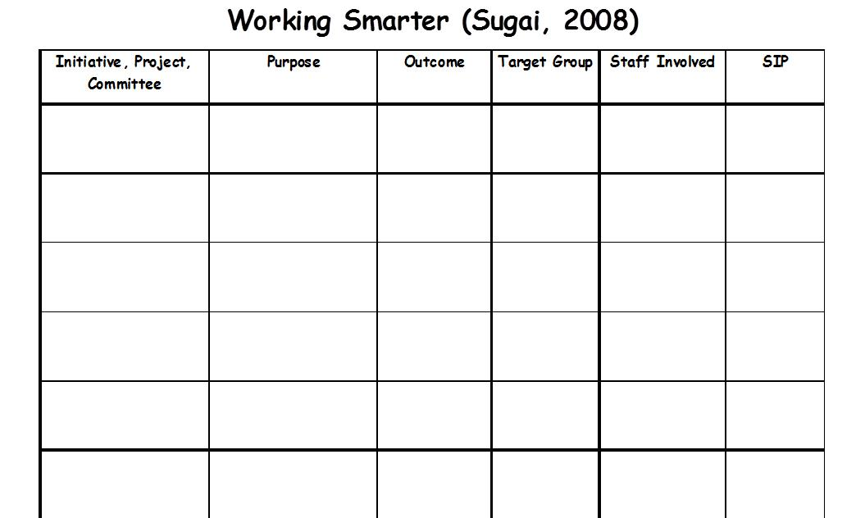

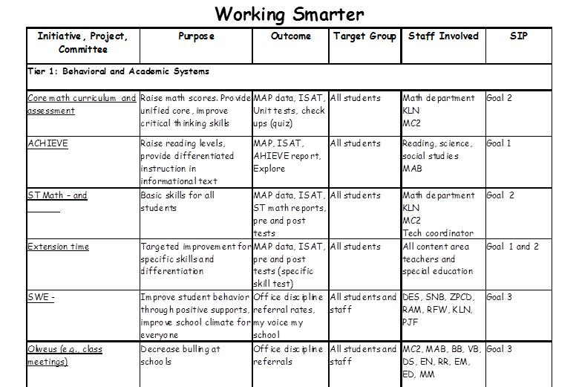

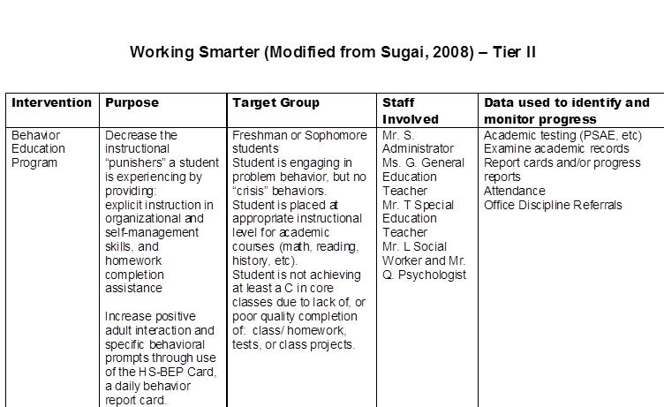

Link to Behavior Education Program: <http://miblsi.cenmi.org/LinkClick.aspx?fileticket=XqRfz3O9AFo%3d&tabid=1855>

Area: **Secondary Pathway – example provided by Marla Dewhirst <marla.r.dewhirst@gmail.com>**

|  |  |  |  |  |
| --- | --- | --- | --- | --- |
| **Criteria for Placement:** | Failing one or more classes (F)  Less than 2.0 GPA  2 credits behind  10% or more absences per year  4 ODR’s per year or 2 per semester  Meets criteria in any area listed above | One or more D’s in any class  2.0 to 2.49 GPA  One credit behind  5% to 9% absences per year  3 ODR’s per year  Meets criteria in any area listed above | C’s or better in all classes  2.5 to 3.75 GPA  Credits will move to next grade level  4% or less absences per year  2 or fewer ODR’s per year  Meets all criteria listed above | 3.75 or higher GPA  95th Percentile on one or more areas  Credits will move to next level  4% or less absences per year  2 or fewer ODR’s per year |

|  |  |  |  |  |  |  |  |  |  |
| --- | --- | --- | --- | --- | --- | --- | --- | --- | --- |
|  | **Intensive** | | | **Strategic** | | | **Benchmark** | | **Advanced** |
| **Instructional Focus:** | Explicit Instruction of Targeted Skills | | | Targeted Skills | | | Universal Expectations for Academics, Study Skills, Behavior and Social Skills | | Extended Learning |
|  | **Academic** | **Behavior** | | **Academic** | | **Behavior** | **Academic** | **Behavior** | **Academic** |
| **Interventions & Intervention**  **Strategies:** | -System 44  -PreAlgebra Select  -Alternative Placement  -Special Education  -Check & Connect  -SPSC Determined Interventions | - E-Net  -Alternative Placement  -CSCT  -Check & Connect  -Home Connections  -Attendance Buy-Back  -SPSC Determined Interventions | | -Mentoring  -Check & Connect  -Check-In Check-Out (CICO)  -ASIST  -Read 180 (Reading Lab)  -Credit Recovery  -PAL  -Applied courses (Biology & English)  -Scheduling  -SBOT/CSCT | | -Mentoring  -Check & Connect  -Check-In Check-Out (CICO)  -Transitions  -SBOT/CSCT  -Home Visits  -Attendance SPSC | -Differentiated Instruction/Co-Teaching  -Star Math/Ed Ready  -Parent Contacts  -Small Learning Communities  -MT Digital Academy  -Great Eight | -Teaching the Capital Code Schoolwide  -Parent Contacts  -Home Visits  -Small Learning Communities  -Great Eight | -Honors Classes in addition to Standard Classes  -AP or IB |
| **Delivery:** | -Student Coordinator  -School Psychologist/School Counselor  -Resource Teachers & Staff  -CSCT & SBOT Staff | | | -Student Coordinator  -School Counselor  -CICO Mentors  -Classroom Teacher | | | All Staff | All Staff | Assigned Staff |
| **Time in delivery:** | >60+ min./week differs from reg. class schedule | | | Approx. 30 to 60 min./week in addition to regular class schedule | | | Standard class Schedule | Standard Class Schedule | Select Schedule |
| **Progess Monitoring:** | -Program Assessments  -Grades  -Weekly AC Checks  -SPSC Review | | -SWIS  -Check & Connect Data  -SPSC Review | -Program Assessments  -Grades  -Bi-Monthly AC Checks | - SWIS  -CICO Data  -SSA Data (Student Self-Assessment Data) | | -Grades  -GPA  -Credits | -Attendance Data  -ODR’s | -Rubrics, Grades & Projects |

**Reflection:** How will you continue to map and organize? How do supports/activities change across the year?

*Consider what communication structures for sharing information and data you have in place now and discuss what opportunities you haven’t explored yet. Record your team’s discussions.*

Determine your next step.

Based on your team time discussion, list at least 2 action statements.

|  |  |  |
| --- | --- | --- |
| **WHAT NEEDS TO BE COMPLETED?** | **WHO** | **WHEN** |
| A. |  |  |
| B. |  |  |
| C. |  |  |
| D. |  |  |

**IV. Organizing multiple data sources**

**Enduring Understanding:** How can you use data to plan for interventions – at the beginning of the year and on-going?

**Essential Questions:** How can teams convert data to a plan of action based on fidelity and outcomes?

**Connections to TASN Innovation Configuration Matrix (ICM):**

LE4: The leadership team regularly engages in formal problem solving using district/building/site level data which is supported by an agile data/software system that provides frequent and up-to-date reports that allow data-based decision making to occur for addressing both academics and behavior. Data are shared with district, building and community.

LE5: The leadership team clearly identifies and implements multiple indicators of academic and behavioral success and formally communicates those indicators as measures of learning.

A1: The assessment system includes tools to measure all essential components of academics and behavior and is used consistently.

A2: The assessment system for academics and behavior includes:

• Universal Screening

• Diagnostic /Functional

Behavioral Assessment

• Progress Monitoring

• Outcomes

**Using Schoolwide Data (Dowdy, Ritchey, and Kamphaus, 2010):**

**Reflective question: Based on what works for using schoolwide data, where are you? What are your action steps?**

1. Establishing a team to guide planning and implementation

2. Identifying the purpose and specific goals for screening within a school settings (SEL - PLC 1)

3. Examining the utility of screening tools in light of the purposes of screening (PLC 2)

4. Selecting screening tools that are linked to goals (PLC 2)

5. Identifying available resources to provide interventions in the school settings based on screening outcomes (PLC 3)

6. Developing a specific timeline and process for data collection (e.g., action plan) (PLC 3)

7. Sharing the results with stakeholders (e.g., teachers, schools, and individual students), studying and reporting data to district level personnel. (PLC 3)

**Sample Dashboard for Schoolwide Review**

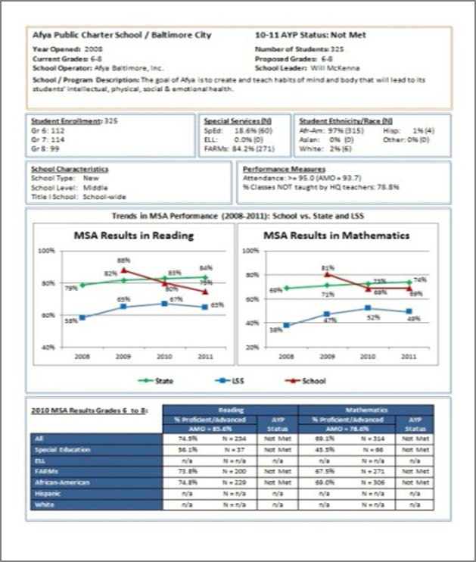

**(From https://www.relmidatlantic.org/forums/creating-and-using-automated-data-dashboards-0)**



**Creating and Using Automated Dashboards** Presented by Rosemarie O’Conner, Ph.D.

**Step 1: Make a model report in Word**

• Create a model of what you want your “final” copy to look like and populate your charts and tables with fictional data

**Step 2: Add bookmarks to your model report**

a) Print your model report and circle or highlight every single detail that needs to change from one report to another – words, numbers, tables, charts, etc.

b) Add bookmarks in Word a. Make your bookmarks visible to keep yourself organized: Word Options → Advanced → Show document contents → Show bookmarks

c) Make a list of every single one of the bookmarks you just created

d) Save this Word document with the bookmarks as a .dotx file (This is called a Word “template”)

**Step 3: Organize the data in Excel**

1. Make a “setup” sheet with 3 columns:

o Column of dashboard data – the column where the datum is going to come from

o Bookmark name

o Short description of the bookmark to keep yourself organized

b) Make a “data” sheet o Transpose the data from the “Setup” into the first 3 rows of the “Data” sheet

o Fill in your data! ▪ Use the =text() function to convert all numbers to text

1. Make your “charts” sheet

o Generate all the charts beforehand (and edit them individually before finalizing the report)

o Each chart has a name, and you have to record that name

**Step 4: Run the code**

a) Code info sheet o Add the name of the template you created

o Add the name of the folder where you want the completed reports to be stored

o Add the row number where the actual data begin

b) Run the macro

(From <https://www.relmidatlantic.org/forums/creating-and-using-automated-data-dashboards-0>)

**Installation and initial implementation: Using data and preparing for your core**

|  |  |
| --- | --- |
|  |  |

|  |  |
| --- | --- |
|  |  |

If these were your data, how would you respond?

Additional Resources

My Voice Survey<http://svsurveys.corwin.com>

My favorite website for using screening data <http://www.ci3t.org>

My favorite book on using screening data – Kathleen Lane *Systematic Screenings of Behavior to Support Instruction: From Preschool to High School*

**Data Next Steps**

**What data are connected to your universal outcomes?**

(Examples: Who is not responding to universal support according to specific criteria: 3 or more major office discipline referrals within a 4- week period; 5 or more unexcused absences in a quarter; 2 or more class failures in a quarter; 5 to 10 nurse visits in a 2-week period; 6 tardies to a class in a quarter; and/or, student failed to complete a minimum of 50% of class assignments in a 2-week period after initiating parent contact and student conferences; Malloy, J., Bohanon, H., Francoeur, K. (In Submission).)

**Where are they?**

**To get these data into a format for decision making:**

Who needs to contacted:

Who needs to approve:

Who needs to be informed:

Who is responsible:

Who can be out of the loop for now: