**Establishing Buy-in for Schoolwide Interventions in Secondary Schools**

**February 23, 2023**

**Montana**

**CEC/CASE Conference**

Hank Bohanon

hbohano@luc.edu

<http://www.hankbohanon.net> (sign up for updates)

<https://twitter.com/hbohano>

<https://www.facebook.com/hank.bohanon>

Please feel free to use these materials. Please let me know if they are helpful to you and how you use them to support your efforts.

**Vermont’s Domains of Safe and Successful School Climates**

|  |  |  |  |
| --- | --- | --- | --- |
| **Safety** | **Physical Environment** | **Teaching and Learning** | **Interpersonal Relationships** |
| __Behavioral Expectations  ___Health & Wellness Expectations  ___Sense of Physical Security  __Sense of Social-Emotional Security | __School Connectedness & Community Engagement  __Physical Surrounding | __Support for Learning  __Social Skills Development  __Student Engagement & Self-Direction | __Respect for Diversity  __Social Supports for Students  __Leadership  __Professional Relationships |

Rate each area on a scale from 1-5. With 5 meaning the component is in place or working well, and 1 meaning the component is not in place or needs improvement.

Bohanon, H., Caputo-Love, L., Morrissey, K. (Accepted). *Preparing secondary school teams to implement systematic interventions.* Routledge Publishing

Vermont Agency of Education (Accessed July 28, 2016). *The 13 dimensions of school climate.* Vermont Agency of Education, Retrieved from: <http://education.vermont.gov/documents/edu-school-climate-13%20Dimensions.pdf>

**What is needed to implement evidence-based approaches? Think about MTSS**

|  |  |  |
| --- | --- | --- |
| **Component** | **In Place/Partially In Place/ Not in Place** | **Result** |
| Support from the administration for the intervention (e.g., principal) |  |  |
| Support from teachers for the intervention (e.g., priority) |  |  |
| Financial resources to sustain the intervention (e.g., FTE) |  |  |
| Training and coaching to increase fidelity of implementation |  |  |
| Alignment of the interventions with the schools’ goals, philosophy, policies, and programs |  |  |
| Program outcomes are visible to all stakeholders |  |  |
| A process is established to address the change in staff and administrators (e.g., plan, manual, specified roles) |  |  |

Bohanon, H., Caputo-Love, L., Morrissey, K. (Accepted). *Preparing secondary school teams to implement systematic interventions.* Routledge Publishing

Forman, S. G., Olin, S. S., Hoagwood, K. E., Crowe, M., & Saka, N. (2009). Evidence-based intervention in schools: Developers' views of implementation barriers and facilitators. *School Mental Health, 1*(1), 26-36. doi:10.1007/s12310-008-9002-5

**Table 5.2**

***Needs Assessment Questions (Based on the Work of Jim Knight)***

**Reflection Task 1**: Briefly respond to each of the questions below on your own or with partners. Complete the reflection activities independently or as a group. If you respond as a group, you just need to focus on one school setting. You can respond individually or as a group. Please include the names of all contributors if you complete this activity as a group.

|  |  |
| --- | --- |
| Question | Response |
| What is going well in your department/school/district for students academically, behavior (e.g., discipline), socially/emotionally, and/or in mental health? |  |
| What are some of the barriers to teaching related to academics, behavior (e.g., discipline), social and emotional learning, and/or mental health? |  |
| What would you like to change about your job around academics, behavior (e.g., discipline), social and emotional learning, and/or mental health? |  |
| Can you say anything about who, when, where, what, and why about problems occur (or what is going well) for students in terms of academics, behavior (e.g., discipline), social and emotional learning, and/or mental health your building? |  |
| What have you liked/disliked about professional development and/or implementing initiatives in the past? |  |

**Questions for Established Teams**

Please answer the questions below about MTSS

1. What do you like MOST about the implementation of MTSS?

2. What do you like LEAST about the implementation of MTSS?

3. How do you feel the implementation of MTSS could be IMPROVED?

4. How often do you deliver acknowledgments?

Circle ONE: Never Monthly Weekly

5. What suggestions do you have for acknowledgments for students? (Think of things

that may or may not cost money).

6. What suggestions do you have for reinforcers for teachers whose names are called

when a student acknowledgement is chosen?

Amy Kroll

9-12 Special Education Teacher/Transition Specialist

1829 Central Ave.

Auburn, NE 68305

(402)-274-4328

akroll@esu4.org

**More Self-Assessment Tools**

Behavior See: – <http://www.pbisapps.org> see Self Assessment Survey;

Academic and behavior Self-Assessment for Buy-In (Niles West High School): <https://docs.google.com/spreadsheet/viewform?usp=sharing&formkey=dHFnSWtjRzdiY1k4M0w0b2kxWHMwNVE6MA#gid=0>

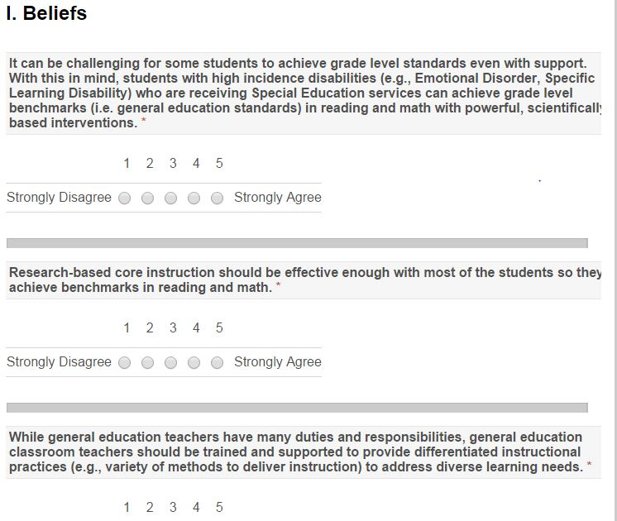

Adapted from http://www.floridarti.usf.edu/resources/program_evaluation/ta_manual_revised2012/index.html - See Tools for Examining Consensus Development

**Table 5.3**

***Summary of Strengths and Next Steps from Needs Assessment***

**Reflection Task 2:** Summarize the main ideas/themes from your responses in Table 5.2. Identify 1-3 strengths for your school (e.g., what is your school doing now that is effective?). Next, identify 1-3 areas of need (i.e., Next Steps) that are needed to improve your setting.Complete the reflection activities independently, or as a group. If you respond as a group, you just need to focus on one school setting. You can respond individually or as a group. Please include the names of all contributors if you complete this activity as a group.

|  |  |
| --- | --- |
| **Strengths** | **Next Steps** |
| (Example: Many of our students are exhibiting excellent behaviors related to citizenship and the behavior we expect in our school) | (Example: We do not know the specific number of students who need additional support to improve their behavior in school) |

**Notes from Conversations with Montana Team Members related to MTSS**

**Strengths:**

* Some schools have been able to re-teach expectations to students as they returned to in-person learning
* Many teachers have learned to use online teaching tools for instruction, which can create more engaging instruction. For example, there are flipped classrooms (e.g., students view online content ahead of the class meeting) that involve the increased use of online tools (e.g., videos, tools). As a result, teachers now provide more opportunities to respond for students, using free, easy-to-use online tools
* Office discipline referrals (ODRs) have reduced as schools have reintroduced their basic expectations
* Many schools are working on developing expectations, giving students increased learning choices, and improving structure and routines for learning
* Schools that provide effective tier one (e.g., schoolwide) instruction and supports have decreased need for more intensive interventions for students
* Most schools provide three tiers of support, even if they are unaware of the structure
* Other

**Next Steps to Address:**

* The transition back to in-person learning was challenging for students
* There were spikes in office discipline referrals as schools could not teach and re-teach their expectations during the pandemic. For example, freshmen had trouble transitioning back to school when they returned
* Some schools have been dealing with increased issues of suicide attempts and completion
* Schools that do not teach and acknowledge expectations or use effective redirection strategies have spikes in their ODRs
* Some teachers feel burnt out..and perhaps do not react as they normally would. Teachers need support in addressing self-care
* Schools are looking at their core instruction. They are asking how their students are students responding. For example, are 80% of their students proficient in math and reading?
* There is a need to align interventions together to prevent overwhelming staff
* Teams need support in adapting schoolwide interventions in smaller-sized schools/districts
* Other

**Working Smarter Triangle**

Take a moment to identify at least one intervention, at each level of the triangle, that your school is currently implementing

|  |  |  |
| --- | --- | --- |
|  | **Academic** | **Behavioral/Social/Emotional** |
| Tier One (for all students) |  |  |
| Tier Two (focusing on 5-15%) |  |  |
| Tier Three (focusing on 5% < |  |  |

You can transfer this information to a PowerPoint Slide if that is helpful ([link](http://www.hankbohanon.net/wp-content/uploads/2022/06/working_smarter_triangle_revised_2020-2-3.ppt))

**Effective Behavior Support Self-Assessment Survey**

**PBIS Action and Commitment Tool (PBIS-ACT) by Kevin Filter**

See this link for more information ([link](https://hss.mnsu.edu/academic-programs/psychology/graduate/school-psychology-psyd/people/faculty/kevin-filter/pbis/))

Filter, K. J., Sytsma, M. R., & McIntosh, K. (2016). A Brief Measure of Staff Commitment to Implement School-Wide Positive Behavioral Interventions and Supports. *Assessment for Effective Intervention, 42*(1), 18-31.

**Table 5 *Tools You Can Use to Get a Sense of What is in Place around MTSS/MTSS***

| Tool | Focus areas | Developer | Link |
| --- | --- | --- | --- |
| Measuring the 7 Stages of Concern | Determining stakeholders’ concerns about an innovation | American Institutes for Research | https://www.sedl.org/cbam/stages_of_concern.html |
| The Hexagon: An Exploration Tool | Evaluate new and existing initiatives – focuses on the program and its fit | State Implementation and Scale-Up of Evidenced-Based Practices | https://sisep.fpg.unc.edu/ |
| North Carolina Self-Assessment of MTSS | Academic and behavior supports | North Carolina Department of Education | www.livebinders.com/play/play?id=2052295#anchor |
| Fidelity Integrity Assessment | MTSS, including all students at risk of failure | SWIFT Center | www.swiftschools.org/shelf |
| Schoolwide Positive Behavior Support Implementation and Planning Self-Assessment | School climate and positive behavior support | Center on Positive Behavioral Interventions and Supports, Schoolwide Positive Behavior Support | www.pbis.org/evaluation/evaluation-tools |
| PBIS Action and Commitment Tool | MTSS | Kevin Filter, University of Minnesota, Mankato | <https://hss.mnsu.edu/academic-programs/psychology/graduate/school-psychology-psyd/people/faculty/kevin-filter/pbis/> |
| Tiered-Fidelity Inventory | MTSS | Center on Positive Behavioral Interventions and Supports, Schoolwide Positive Behavior Support | www.pbis.org/evaluation/evaluation-tools |
| School-Based Mental Health Capacity Instrument | School-Based Mental Health | Feigenberg, Watts, and Buckner (2010) | https://link.springer.com/article/10.1007/s12310-010-9041-6 |
| Center for Academic, Social, and Emotional Learning Self-Assessment Rubric | Whole Child | Center for Academic, Social, and Emotional Learning | https://casel.org/guide |
| OPI MTSS Staff Consensus Survey | MTSS | Montant Office of Public Instruction | <https://opi.mt.gov/LinkClick.aspx?fileticket=pRYYhm_ske8%3d&portalid=182> |

**Table 5.6**

***What Data already Exists in Each of the 4 Domains of Schools***

**Reflection Task 3:** Take a few minutes to identify any data you might already have in your school related to these areas of an effective school climate. You only need to identify data in areas where you have them. You can respond individually or as a group. Please include the names of all contributors if you complete this activity as a group.

|  |  |
| --- | --- |
| Safety  (Example: Discipline reports) | Teaching and Learning  (Example: Student grades, visits to nurse) |
| Physical Environment  (Example: Observations, maintenance reports) | Interpersonal Relationships  (Example: Student surveys, classroom observations) |

**Preparing for Resistance**

**Team Member:** “I think we should review data from our students about their perceptions of school climate”

**Adminstrator Alice Welly (all is well):** “Our programs are well designed, you are implying that we have failed.”

**Attack # 4 based on John Kotter’s Book *Buy-In (***[***link***](https://www.kotterinc.com/book/buy-in/)***)***

**#4 "You're saying we've failed??!!" Attack:** “If this is a problem, then what you are telling us is that we have been doing a lousy job. That's insulting!”

**Sample Response:** “No, we're suggesting that you are doing a remarkably good job without the needed tools (systems, methods, laws, etc) which, in our proposal, you will have.”

**Based on this example response, how would you respond to Alice?**

**See the next page for the team member’s response (after you have tried to respond).**

**Actual Response from Team Member**

**Team Member:** “I think your programs are going very well, given we just need to add systems to help take them to another level.”

**Adminstrator Alice Welly:** “That was the most important thing you have said all day.”

**Activity:** Review “Early Stages for implementation”

Given your current setting –where are you in the Exploration Phase?

What might be some key experiences you can use to bring along your staff?

Link to article <http://ecommons.luc.edu/education_facpubs/17/>

**Reflection:** How will you encourage your teams to meet effectively?